**Sheetal_ Sekhar (NUID- 001437674)**

**DMDD Final Project**



This project is about Hersheys chocolate world, which is a manufacturing unit.

With the help of ER diagram meaningful relations between products, orders and order items are known.

Milton Hershey, the founder of the Hershey's brand, first experimented with making chocolate as a coating for caramels in 1894. In 1900, the first actual Hershey's milk chocolate bar was produced and sold in America. It involves a variety of products and a database is needed to maintain its entire working.

**ENTITIES**

* **Consumer**: Information about the person( details like consumerId, Name, Address, Birth date).
* **Payment Method**: Card details entered by the user to purchase the chocolates.
* **Products**: The products available in the factory.
* **OrderItems**: The orders placed are here.

TRIGGER

**Create Trigger**

1. Creating a Table to store the Trigger

create table TriggerResultOnOrders(

triggerId int primary key , UserName varchar(25), Date timestamp );

desc TriggerResultOnOrders;

select * from TriggerResultOnOrders;

**Writing the Trigger**

DELIMITER //

create trigger TriggerResultOnOrders2

after insert

on orders

FOR EACH ROW

Begin

insert into TriggerResultOnOrders

values (1,user(),now());

END;

//

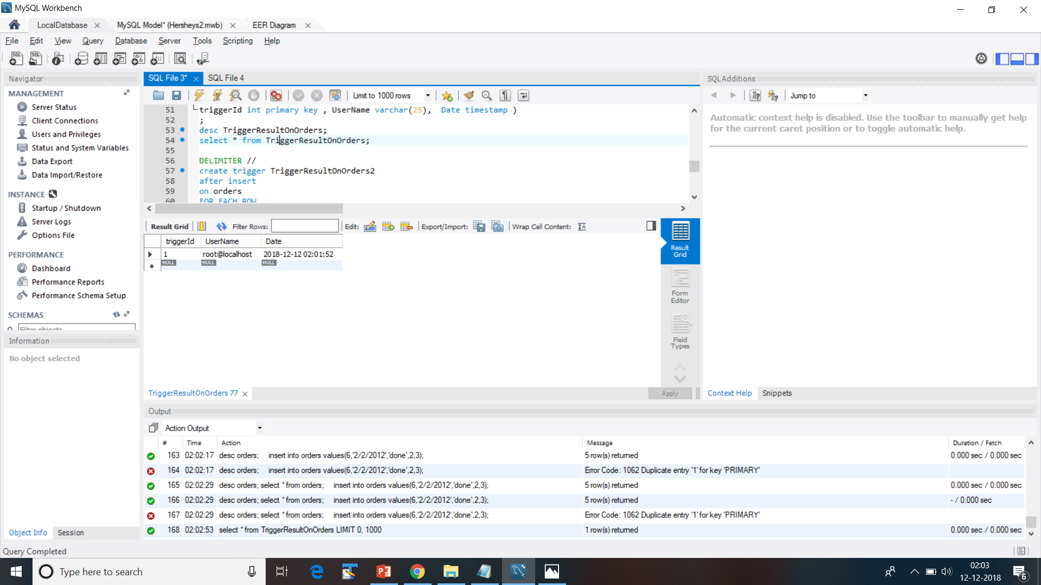

**Inner Joins**

**From tables- Customer has payment methods and payment methods**

select customer_has_payment_methods.Consumer_idConsumer,payment_methods.TypeOfPayment from customer_has_payment_methods inner join payment_methods

on customer_has_payment_methods.Payment_Methods_idPayment_Methods=payment_methods.idPayment_Methods;

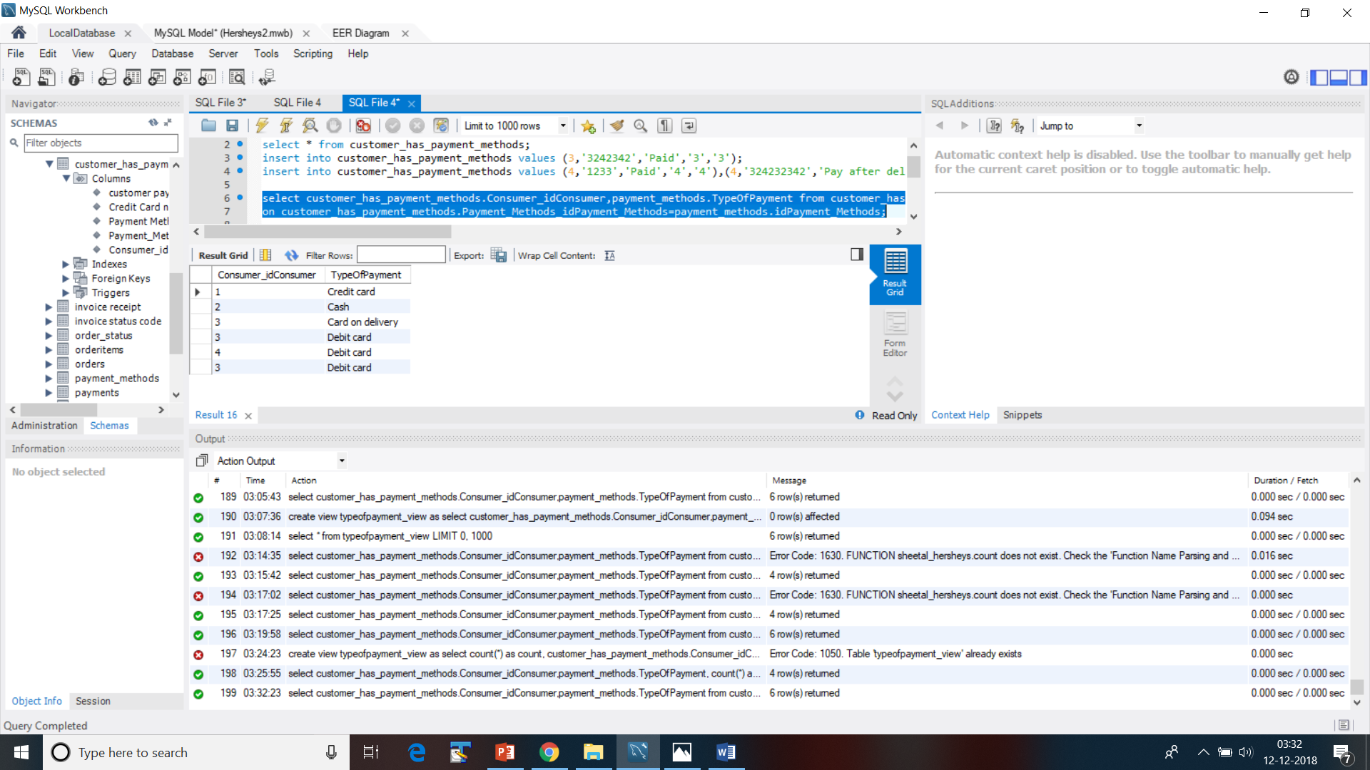

Making this as a view so that it’s easily accessible anytime.

create view **typeofpayment_view** as select customer_has_payment_methods.Consumer_idConsumer,payment_methods.TypeOfPayment from customer_has_payment_methods inner join payment_methods on customer_has_payment_methods.Payment_Methods_idPayment_Methods=payment_methods.idPayment_Methods;

select * from **typeofpayment_view;**

**select * from payment_methods**

**Result as below:**

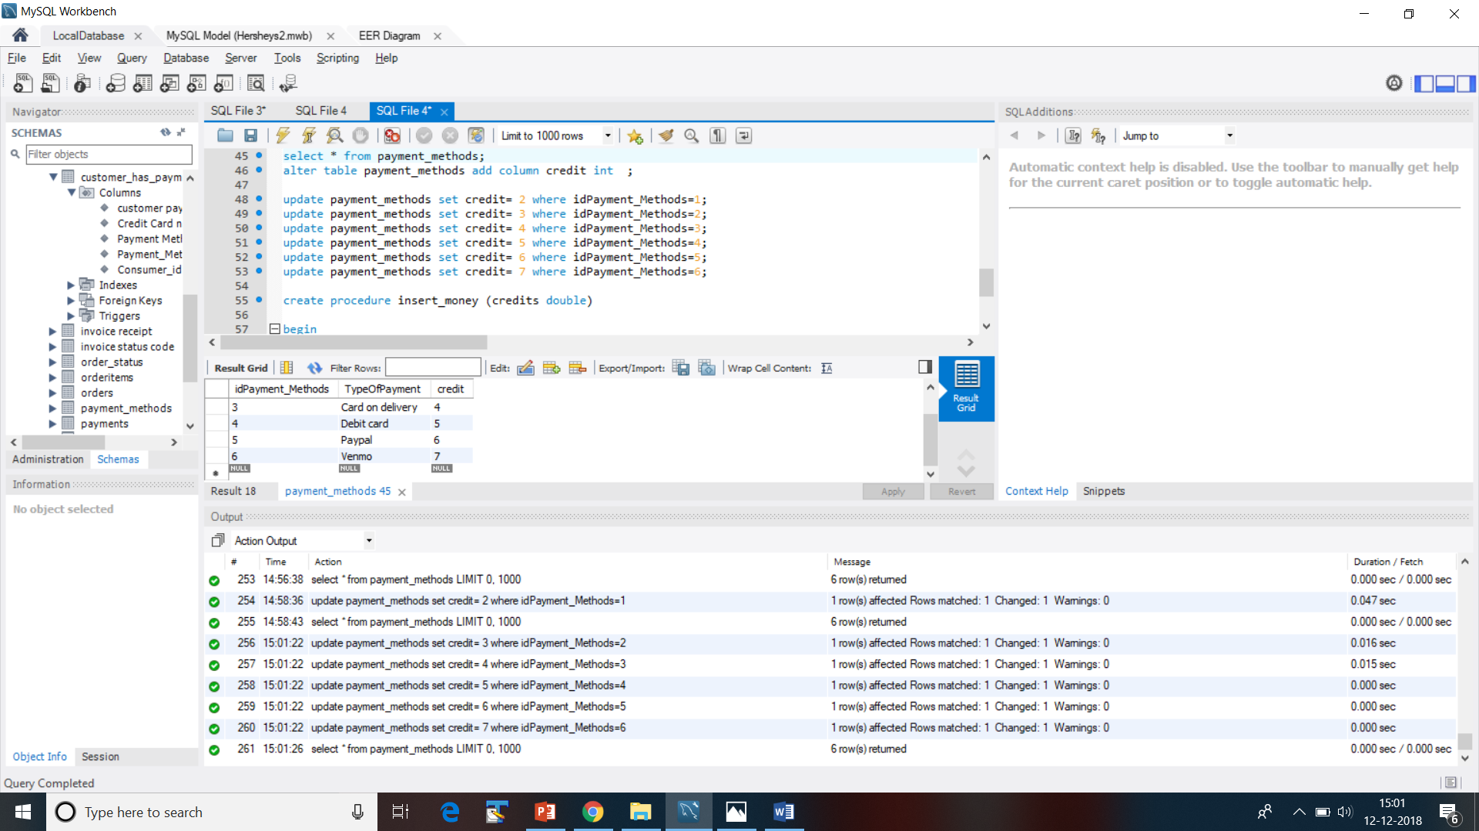

**select * from payment_methods;**

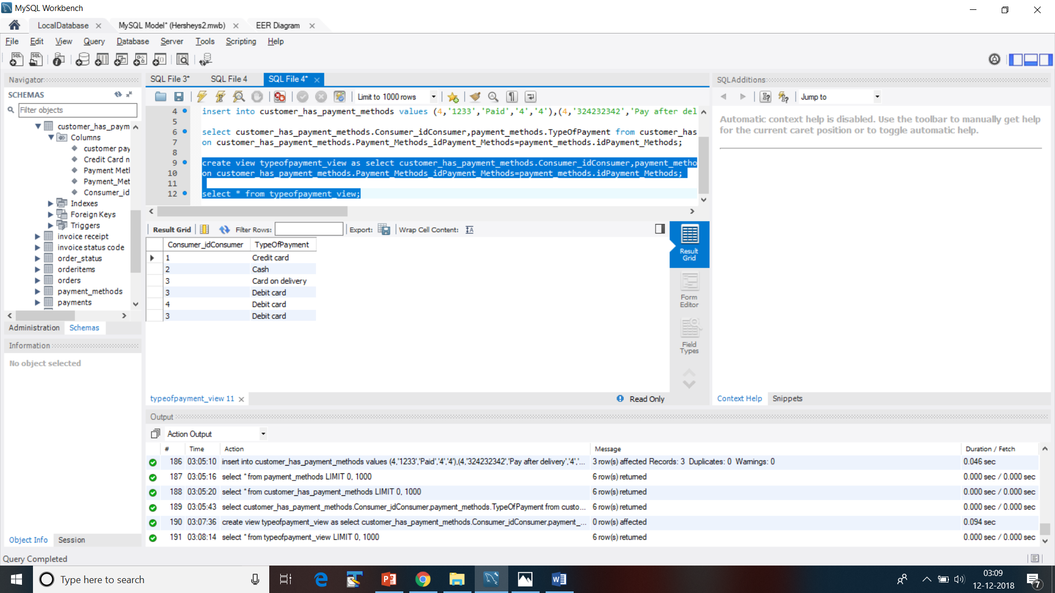

This is a query to see which type of payment type is used the most, using count aggregate function combined with group and having.

**select customer_has_payment_methods.Consumer_idConsumer,payment_methods.TypeOfPayment, count(*) as count from customer_has_payment_methods inner join payment_methods**

**on customer_has_payment_methods.Payment_Methods_idPayment_Methods=payment_methods.idPayment_Methods group by payment_methods.TypeOfPayment having count(customer_has_payment_methods.Consumer_idConsumer) order by customer_has_payment_methods.Consumer_idConsumer;**

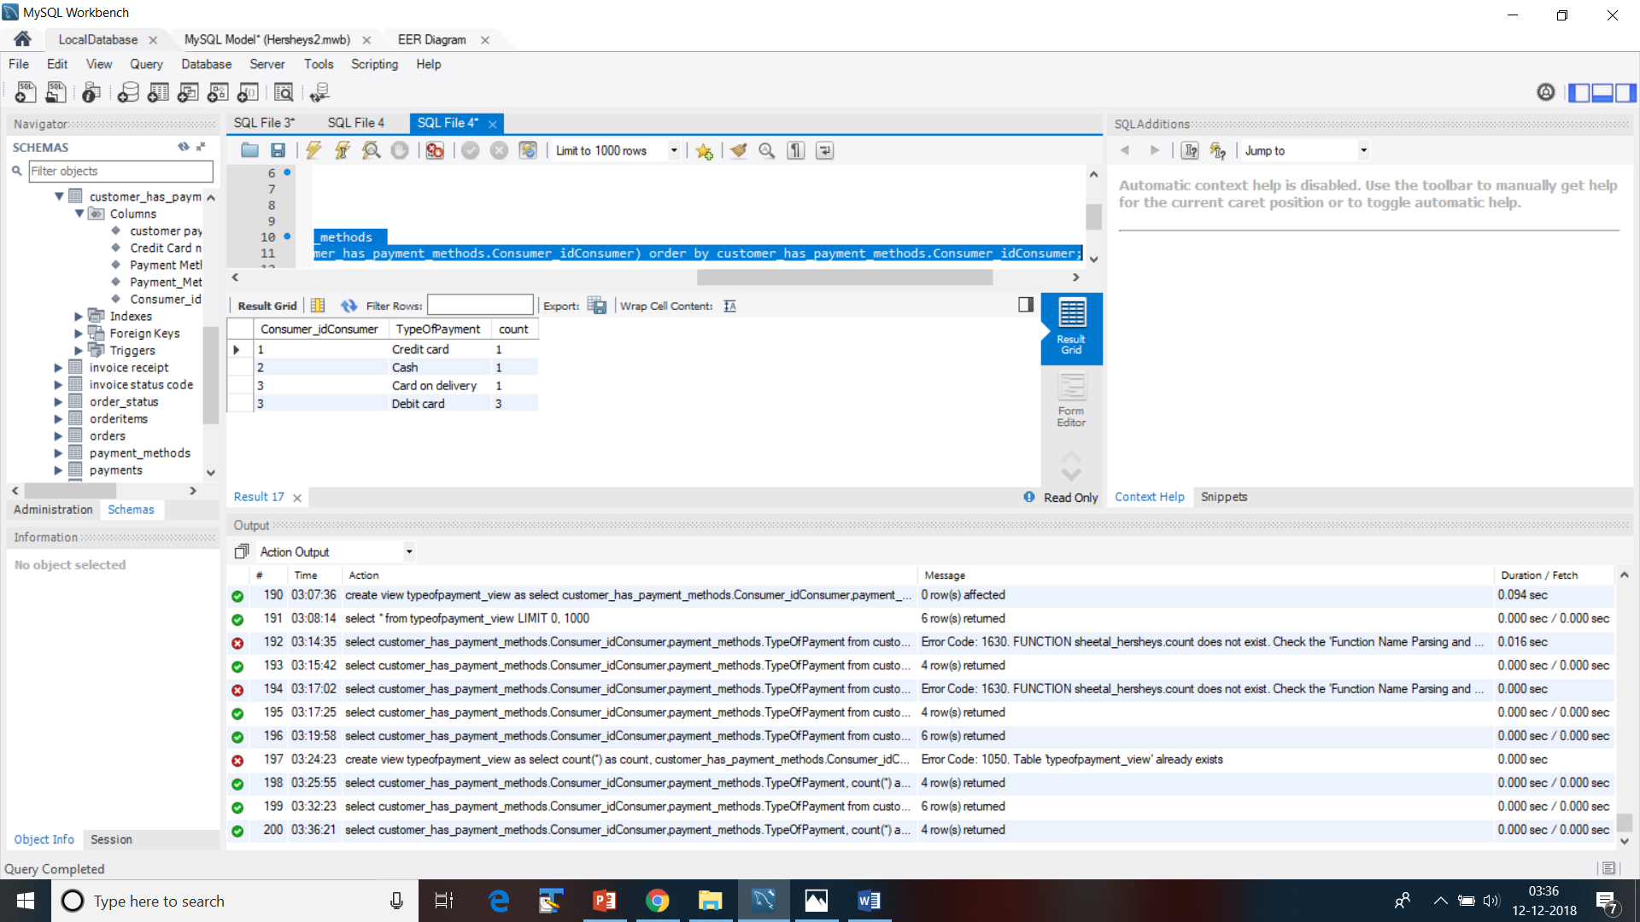

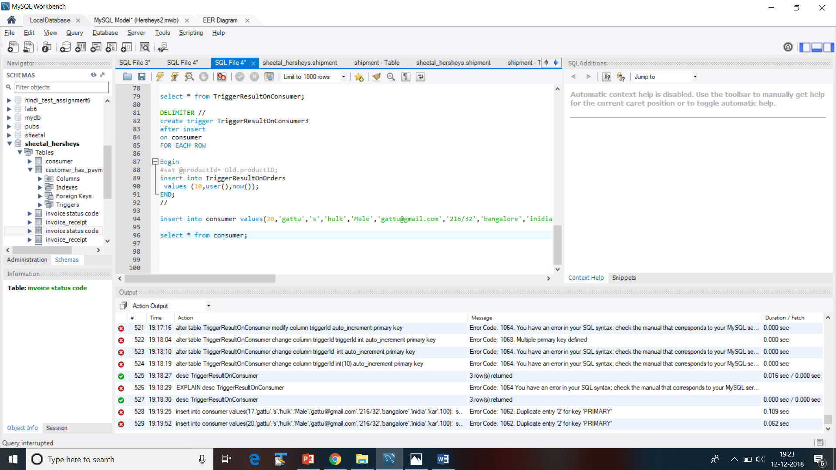

**This is another Trigger between the consumer table and a new Table was created for the logs to get entered- tblConsumerTrackrecord.**

**select * from tblConsumerTrackrecord;**

DELIMITER //

create trigger trigger1

after insert

on consumer

FOR EACH ROW

Begin

insert into tblConsumerTrackrecord

(

consumerId,

actionPerformed ,

updatedBy,

updatedOn) values (consumerId,"INSERT",user(),now());

END;

// DELIMITER ;

select * from TriggerResultOnOrders;

**Cursor**

DELIMITER $$

CREATE PROCEDURE build_email_list (INOUT email_list varchar(4000))

BEGIN

DECLARE v_finished INTEGER DEFAULT 0;

DECLARE v_email varchar(100) DEFAULT "";

-- declare cursor for employee email

DEClARE email_cursor CURSOR FOR

SELECT Email FROM consumer;

-- declare NOT FOUND handler

DECLARE CONTINUE HANDLER

FOR NOT FOUND SET v_finished = 1;

OPEN email_cursor;

get_email: LOOP

FETCH email_cursor INTO v_email;

IF v_finished = 1 THEN

LEAVE get_email;

END IF;

-- build email list

SET email_list = CONCAT(v_email,";",email_list);

END LOOP get_email;

CLOSE email_cursor;

END$$

DELIMITER ;

SET @email_list = "";

CALL build_email_list(@email_list);

SELECT @email_list;

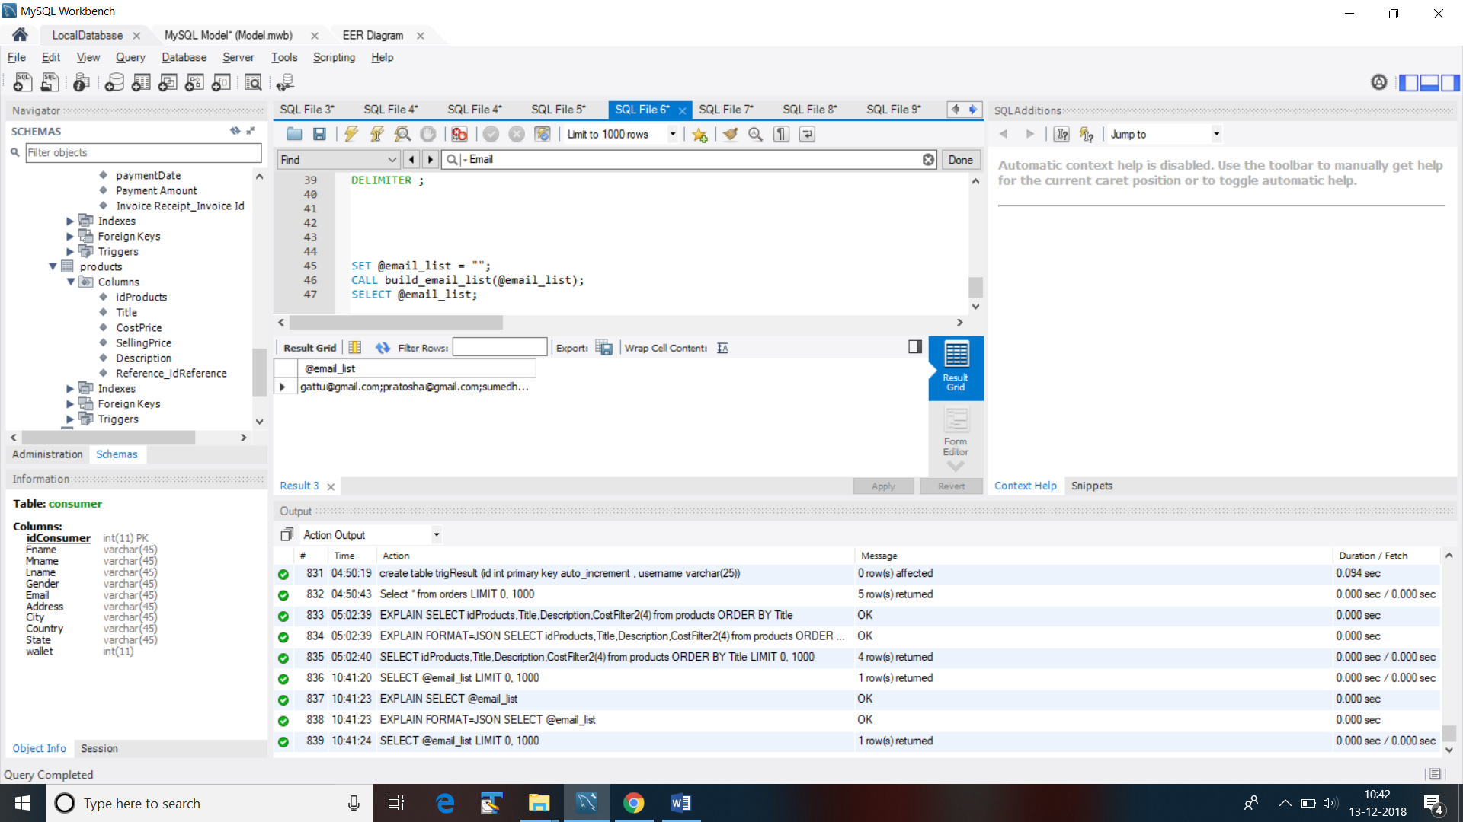

***Procedure:***

select * from consumer;

delimiter //

create procedure procConsumer1 (IN id int )

Begin

Select * from consumer where idConsumer=id;

end//

delimiter ;

**Call** procConsumer1 **(2);**

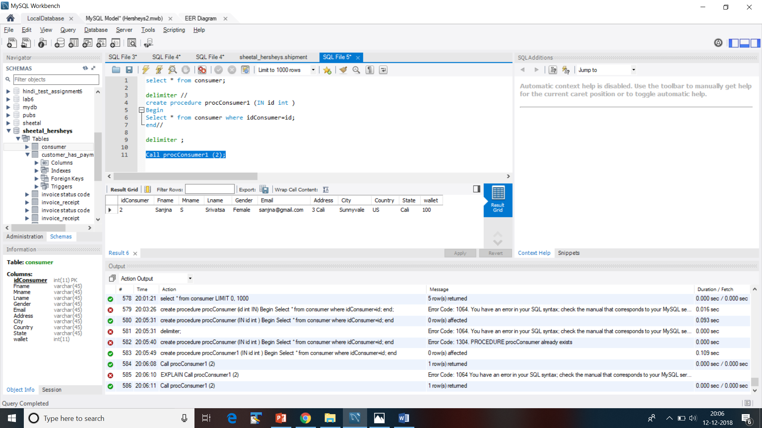

**Using 2 left joins**

**2 tables have been joined**

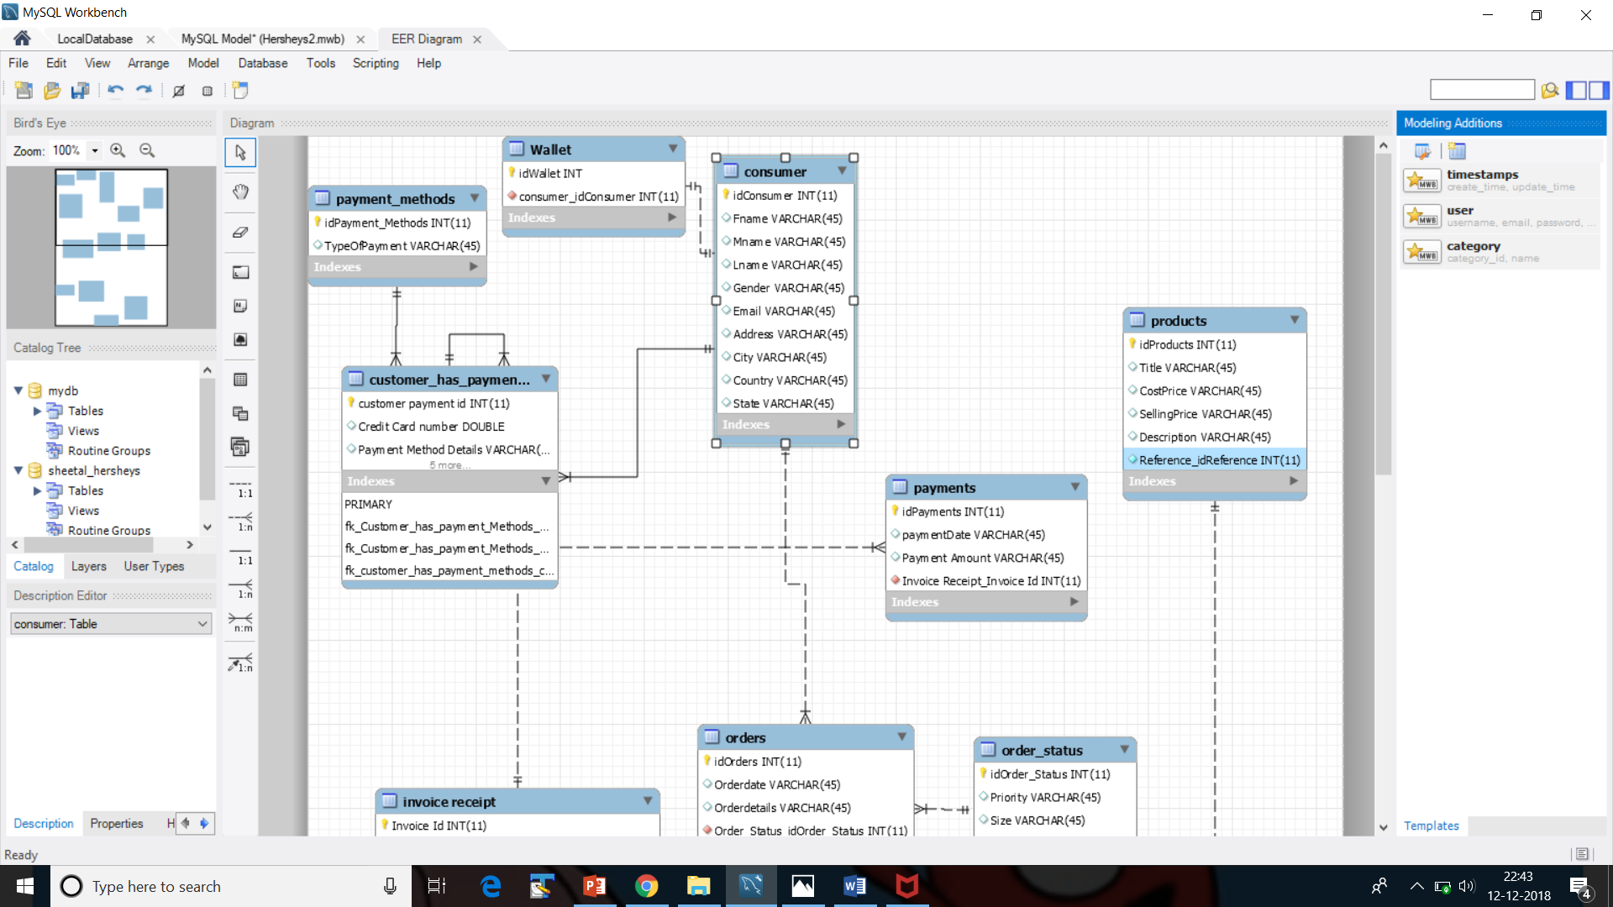

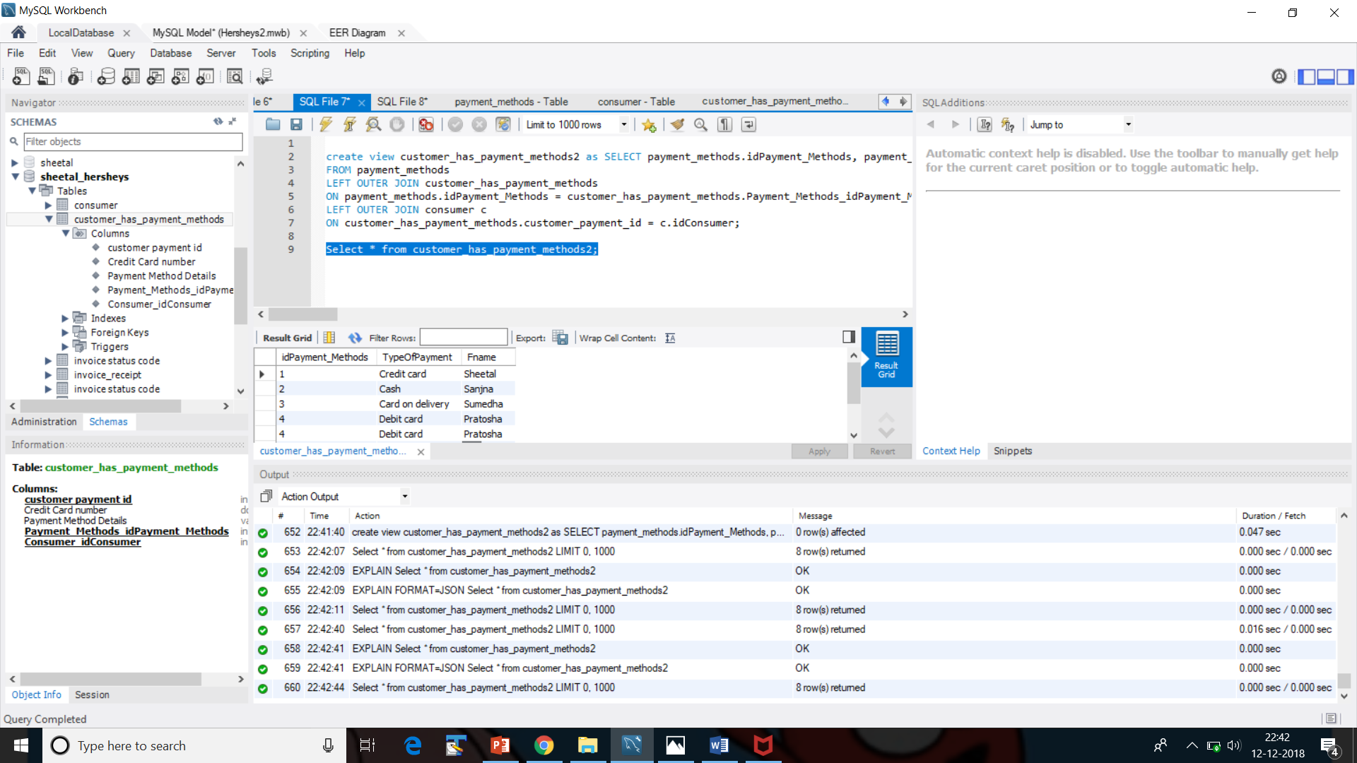

**The 2 tables are payment_methods and consumer**

**The bridge table is** customer_has_payment_methods

**Creating a view to display the corresponding Consumer name from idpayment and payment type.**

create view customer_has_payment_methods2 as SELECT payment_methods.idPayment_Methods, payment_methods.TypeOfPayment, c.Fname

FROM payment_methods

LEFT OUTER JOIN customer_has_payment_methods

ON payment_methods.idPayment_Methods = customer_has_payment_methods.Payment_Methods_idPayment_Methods

LEFT OUTER JOIN consumer c

ON customer_has_payment_methods.customer_payment_id = c.idConsumer;

Select * from customer_has_payment_methods2**;**

**Creating users and granting user privileges**

CREATE USER 'sheetal3'@'localhost%'

IDENTIFIED BY 'password12';

select host, user from mysql.user where user like 's%';

grant all privileges on test.* to 'sheetal3'@'localhost%';

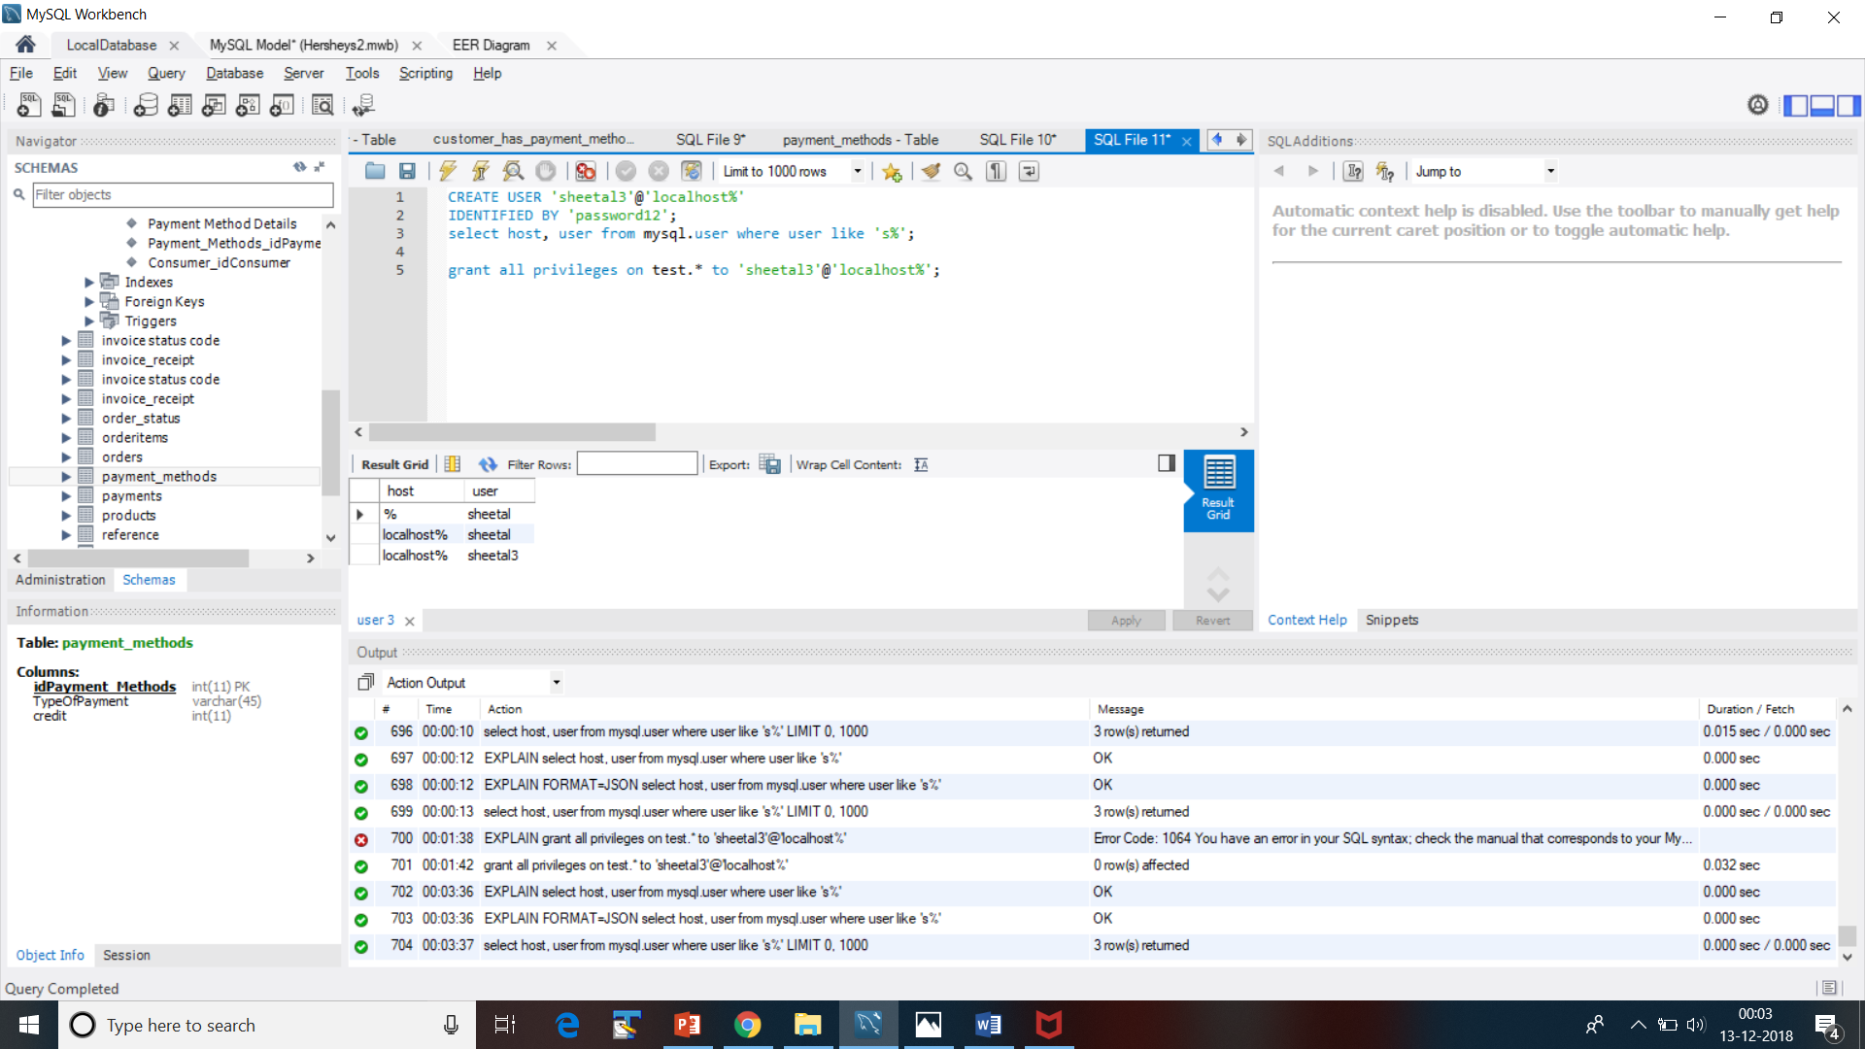

**Transactions**

start transaction;

savepoint pitstop1;

update consumer set Fname=Vishal where idConsumer=1;

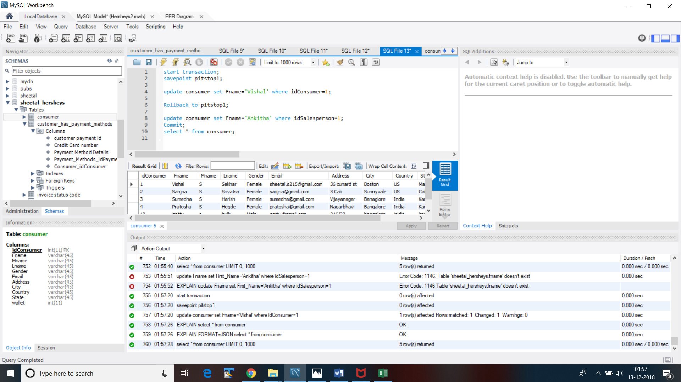

Rollback to pitstop1;

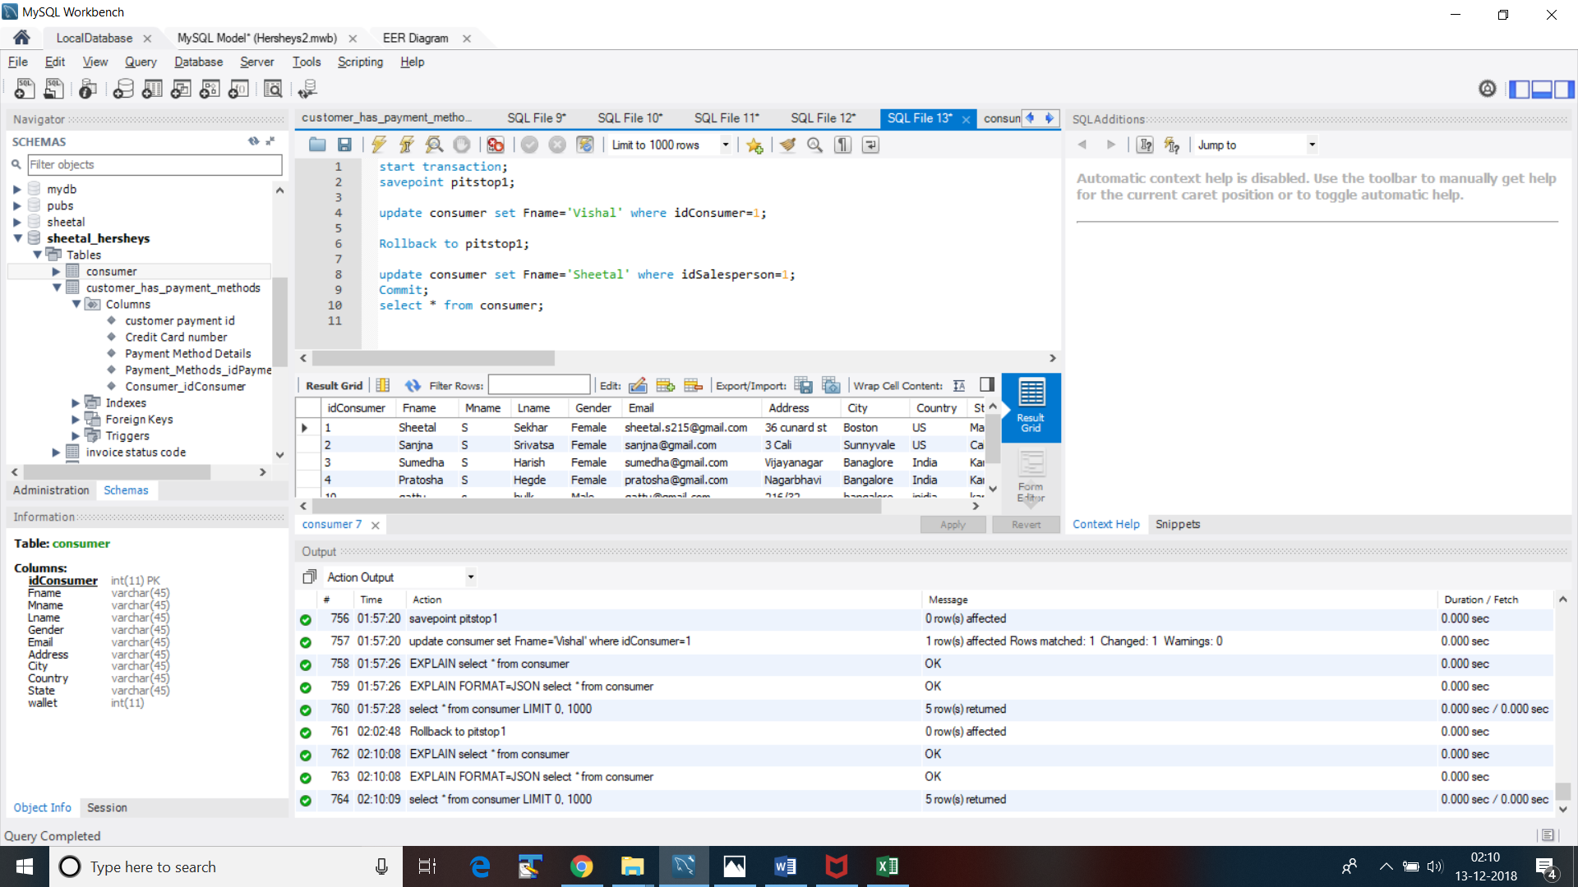

It’s rolled back to Sheetal as Fname;

update salesperson set Fname ="Sheetu" where idConsumer=1;

Commit;

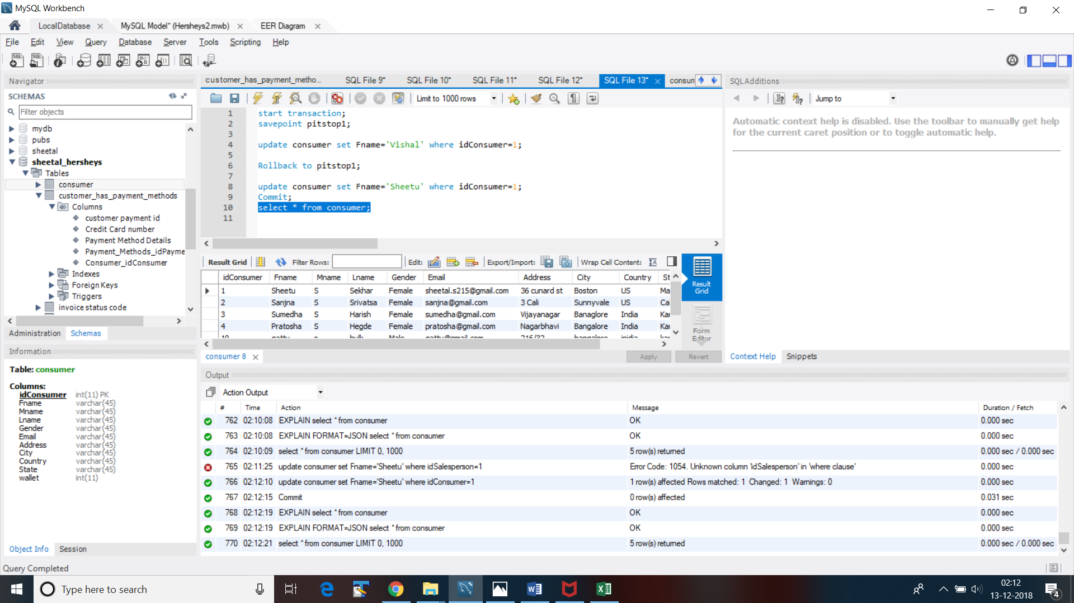

New Values are as above.

**Outfile- Storing all the contents into a .csv file with some conditions for further use.**

Select * from Products;

SELECT 'Id Name', 'Title', 'Description'

UNION ALL

SELECT

Products.idProducts,

Products.Title,

Products.Description into outfile 'D:/sheetalProducts4.csv'

FIELDS TERMINATED BY ','

ENCLOSED BY '"'

FROM Products

WHERE Products.SellingPrice BETWEEN 2 And 5;

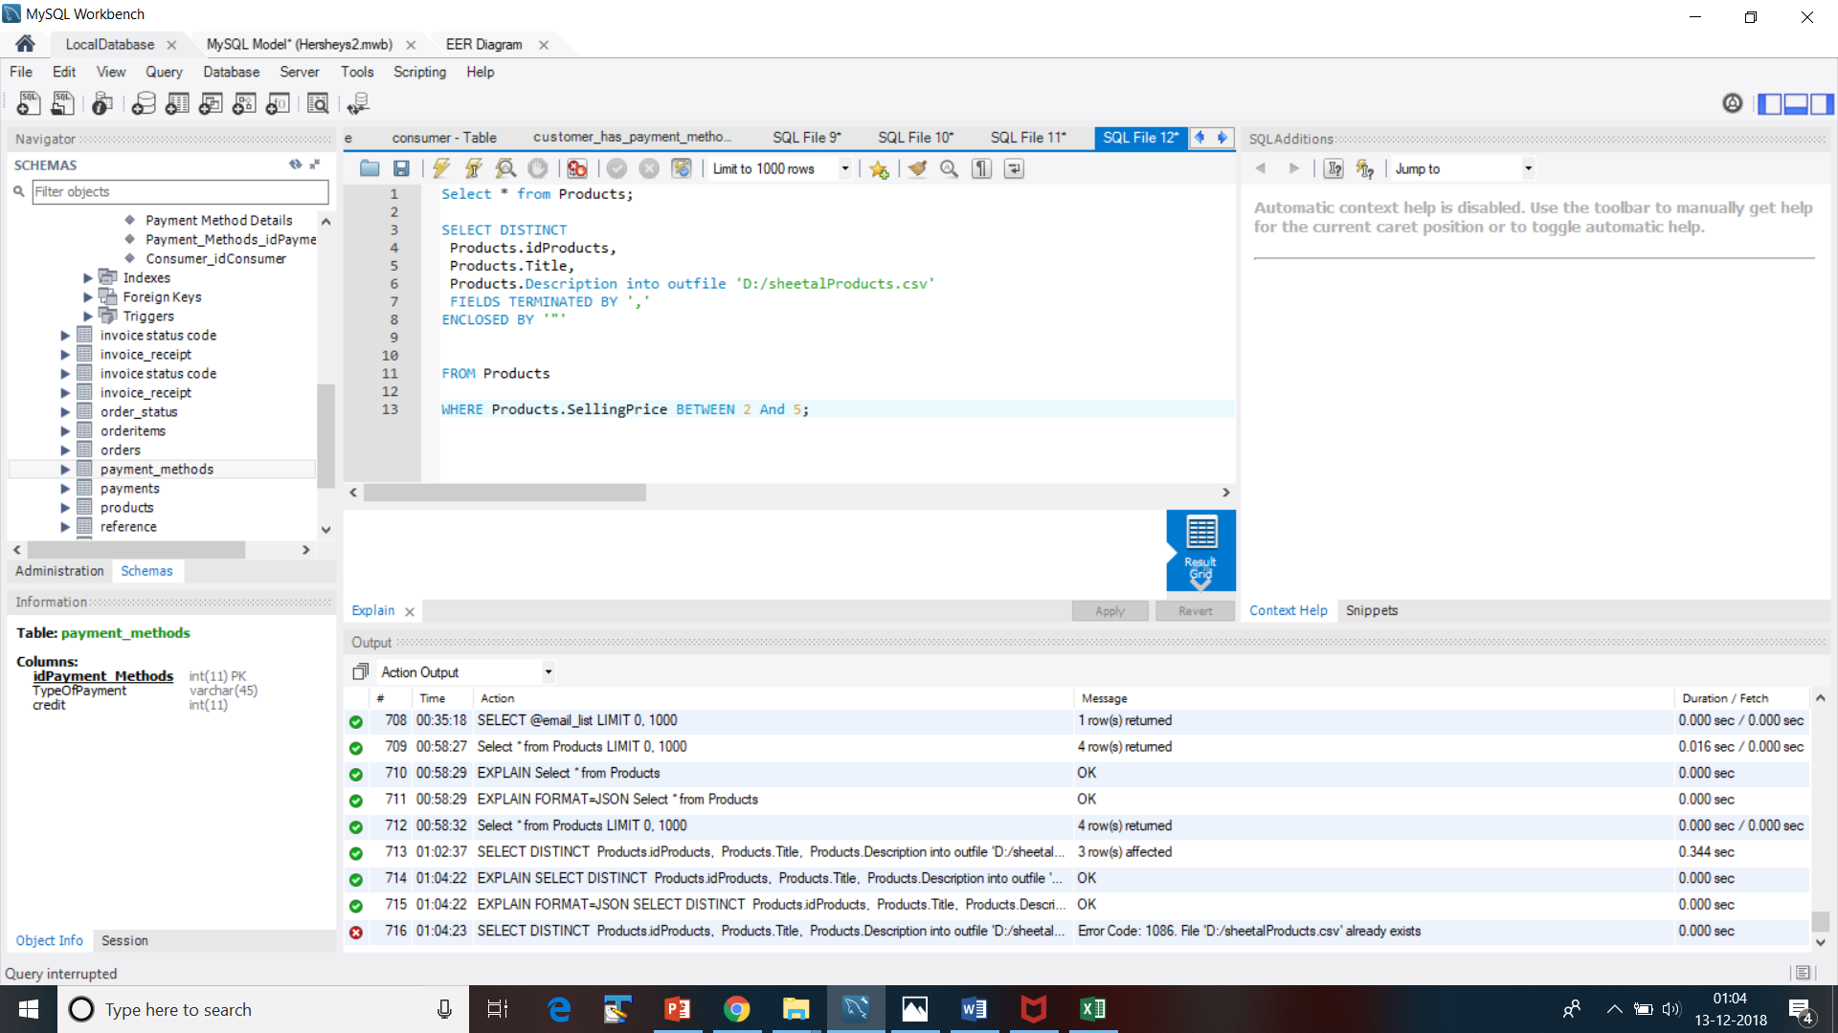

**Stored into an Excel file**

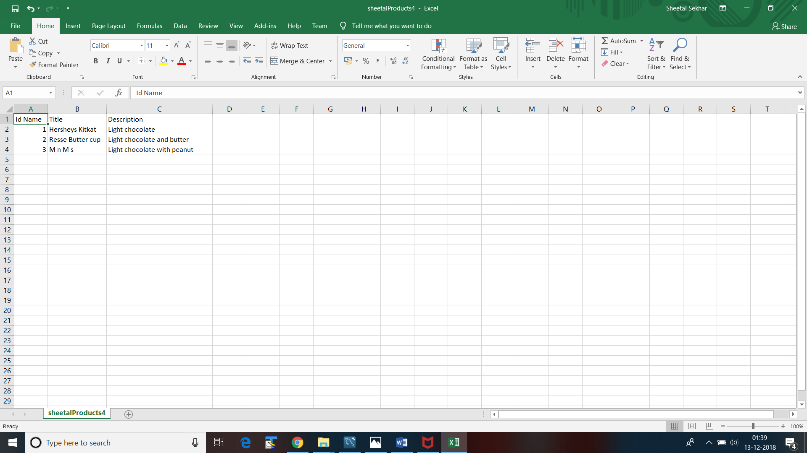

**User-Defined-**

DELIMITER $$

CREATE FUNCTION CostFilter2(amt int) RETURNS VARCHAR(40)

DETERMINISTIC

BEGIN

DECLARE CostFilterCheck varchar(10);

IF amt > 5.5 THEN

SET CostFilterCheck = 'Very Costly';

ELSEIF (amt >= 4.5 AND amt <= 5.5) THEN

SET CostFilterCheck = 'Costly';

ELSEIF amt >=3.5 AND amt <=4.5 THEN

SET CostFilterCheck = 'Reasonable';

END IF;

RETURN (CostFilterCheck);

END $$

DELIMITER ;

Query:

SELECT idProducts,Title,Description,CostFilter2(4) from products ORDER BY Title;

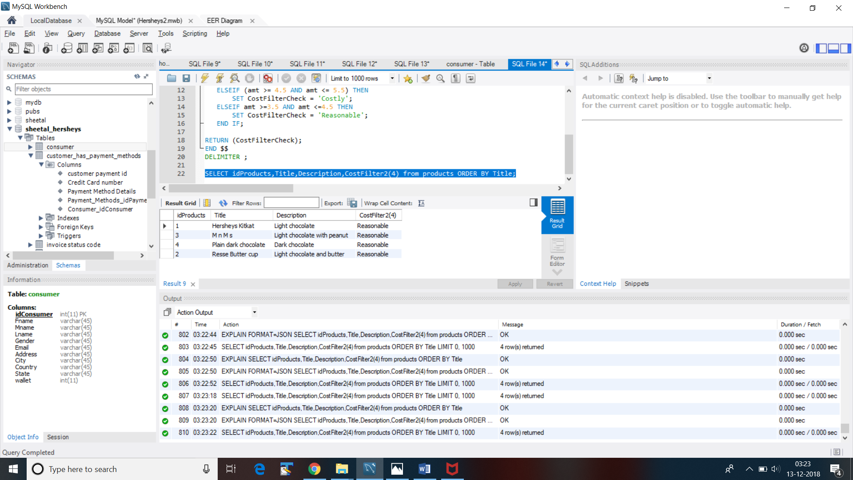

**INDEX**

CREATE INDEX nameInderonP ON products (Title);

DELIMITER $$

CREATE PROCEDURE SearchTitle(IN p varchar(45))

BEGIN

SELECT CostPrice

FROM products

WHERE Title = p;

END $$

DELIMITER ;

select * from products;

call SearchTitle('M n M s');

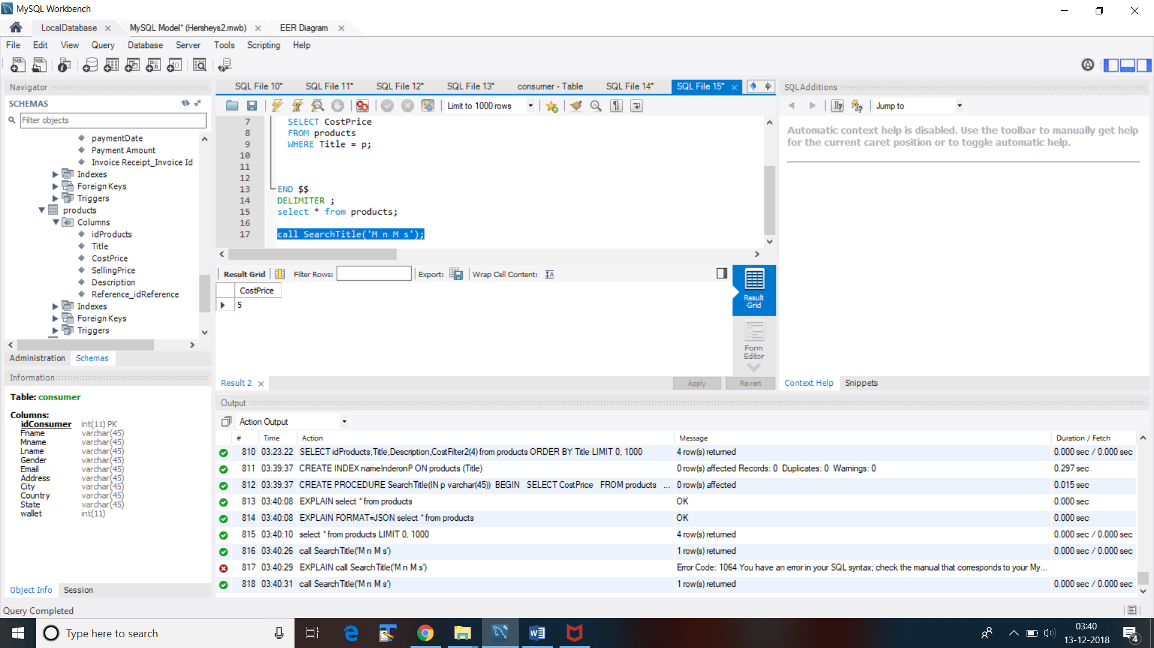

E-R Diagram

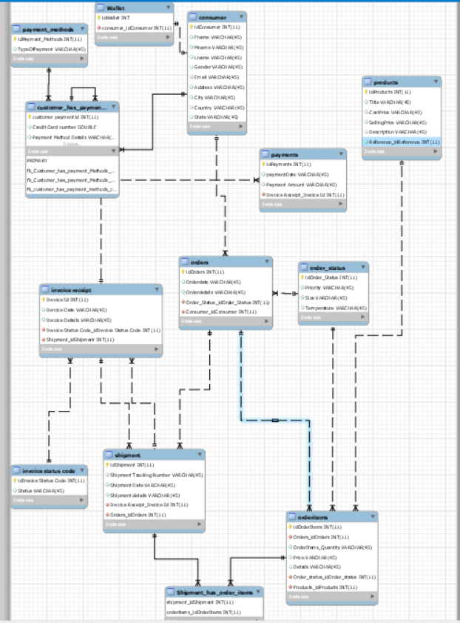

**SQL- dump**

CREATE DATABASE IF NOT EXISTS `sheetal_hersheys` /*!40100 DEFAULT CHARACTER SET utf8mb4 COLLATE utf8mb4_0900_ai_ci */;

USE `sheetal_hersheys`;

-- MySQL dump 10.13 Distrib 8.0.12, for Win64 (x86_64)

--

-- Host: 127.0.0.1 Database: sheetal_hersheys

-- ------------------------------------------------------

-- Server version 8.0.12

/*!40101 SET @OLD_CHARACTER_SET_CLIENT=@@CHARACTER_SET_CLIENT */;

/*!40101 SET @OLD_CHARACTER_SET_RESULTS=@@CHARACTER_SET_RESULTS */;

/*!40101 SET @OLD_COLLATION_CONNECTION=@@COLLATION_CONNECTION */;

SET NAMES utf8 ;

/*!40103 SET @OLD_TIME_ZONE=@@TIME_ZONE */;

/*!40103 SET TIME_ZONE='+00:00' */;

/*!40014 SET @OLD_UNIQUE_CHECKS=@@UNIQUE_CHECKS, UNIQUE_CHECKS=0 */;

/*!40014 SET @OLD_FOREIGN_KEY_CHECKS=@@FOREIGN_KEY_CHECKS, FOREIGN_KEY_CHECKS=0 */;

/*!40101 SET @OLD_SQL_MODE=@@SQL_MODE, SQL_MODE='NO_AUTO_VALUE_ON_ZERO' */;

/*!40111 SET @OLD_SQL_NOTES=@@SQL_NOTES, SQL_NOTES=0 */;

--

-- Table structure for table `consumer`

--

DROP TABLE IF EXISTS `consumer`;

/*!40101 SET @saved_cs_client = @@character_set_client */;

SET character_set_client = utf8mb4 ;

CREATE TABLE `consumer` (

`idConsumer` int(11) NOT NULL,

`Fname` varchar(45) DEFAULT NULL,

`Mname` varchar(45) DEFAULT NULL,

`Lname` varchar(45) DEFAULT NULL,

`Gender` varchar(45) DEFAULT NULL,

`Email` varchar(45) DEFAULT NULL,

`Address` varchar(45) DEFAULT NULL,

`City` varchar(45) DEFAULT NULL,

`Country` varchar(45) DEFAULT NULL,

`State` varchar(45) DEFAULT NULL,

`wallet` int(11) DEFAULT '100',

PRIMARY KEY (`idConsumer`)

) ENGINE=InnoDB DEFAULT CHARSET=utf8mb4 COLLATE=utf8mb4_0900_ai_ci;

/*!40101 SET character_set_client = @saved_cs_client */;

--

-- Dumping data for table `consumer`

--

LOCK TABLES `consumer` WRITE;

/*!40000 ALTER TABLE `consumer` DISABLE KEYS */;

INSERT INTO `consumer` VALUES (1,'Sheetu','S','Sekhar','Female','sheetal.s215@gmail.com','36 cunard st','Boston','US','Mas',100),(2,'Sanjna','S','Srivatsa','Female','sanjna@gmail.com','3 Cali','Sunnyvale','US','Cali',100),(3,'Sumedha','S','Harish','Female','sumedha@gmail.com','Vijayanagar','Banaglore','India','Karnataka',100),(4,'Pratosha','S','Hegde','Female','pratosha@gmail.com','Nagarbhavi','Bangalore','India','Karnatka',100),(10,'gattu','s','hulk','Male','gattu@gmail.com','216/32','bangalore','inidia','kar',100);

/*!40000 ALTER TABLE `consumer` ENABLE KEYS */;

UNLOCK TABLES;

/*!50003 SET @saved_cs_client = @@character_set_client */ ;

/*!50003 SET @saved_cs_results = @@character_set_results */ ;

/*!50003 SET @saved_col_connection = @@collation_connection */ ;

/*!50003 SET character_set_client = utf8mb4 */ ;

/*!50003 SET character_set_results = utf8mb4 */ ;

/*!50003 SET collation_connection = utf8mb4_0900_ai_ci */ ;

/*!50003 SET @saved_sql_mode = @@sql_mode */ ;

/*!50003 SET sql_mode = 'STRICT_TRANS_TABLES,NO_ENGINE_SUBSTITUTION' */ ;

DELIMITER ;;

/*!50003 CREATE*/ /*!50017 DEFINER=`root`@`localhost`*/ /*!50003 TRIGGER `TriggerResultOnConsumer2` AFTER INSERT ON `consumer` FOR EACH ROW Begin

#set @productId= Old.productID;

insert into TriggerResultOnOrders

values (2,user(),now());

END */;;

DELIMITER ;

/*!50003 SET sql_mode = @saved_sql_mode */ ;

/*!50003 SET character_set_client = @saved_cs_client */ ;

/*!50003 SET character_set_results = @saved_cs_results */ ;

/*!50003 SET collation_connection = @saved_col_connection */ ;

/*!50003 SET @saved_cs_client = @@character_set_client */ ;

/*!50003 SET @saved_cs_results = @@character_set_results */ ;

/*!50003 SET @saved_col_connection = @@collation_connection */ ;

/*!50003 SET character_set_client = utf8mb4 */ ;

/*!50003 SET character_set_results = utf8mb4 */ ;

/*!50003 SET collation_connection = utf8mb4_0900_ai_ci */ ;

/*!50003 SET @saved_sql_mode = @@sql_mode */ ;

/*!50003 SET sql_mode = 'STRICT_TRANS_TABLES,NO_ENGINE_SUBSTITUTION' */ ;

DELIMITER ;;

/*!50003 CREATE*/ /*!50017 DEFINER=`root`@`localhost`*/ /*!50003 TRIGGER `trigger1` AFTER INSERT ON `consumer` FOR EACH ROW Begin

insert into tblConsumerTrackrecord

(

consumerId,

actionPerformed ,

updatedBy,

updatedOn) values (consumerId,"INSERT",user(),now());

END */;;

DELIMITER ;

/*!50003 SET sql_mode = @saved_sql_mode */ ;

/*!50003 SET character_set_client = @saved_cs_client */ ;

/*!50003 SET character_set_results = @saved_cs_results */ ;

/*!50003 SET collation_connection = @saved_col_connection */ ;

--

-- Table structure for table `customer_has_payment_methods`

--

DROP TABLE IF EXISTS `customer_has_payment_methods`;

/*!40101 SET @saved_cs_client = @@character_set_client */;

SET character_set_client = utf8mb4 ;

CREATE TABLE `customer_has_payment_methods` (

`customer_payment_id` int(11) NOT NULL,

`Credit Card number` double DEFAULT NULL,

`Payment Method Details` varchar(45) DEFAULT NULL,

`Payment_Methods_idPayment_Methods` int(11) NOT NULL,

`Consumer_idConsumer` int(11) NOT NULL,

PRIMARY KEY (`customer_payment_id`,`Payment_Methods_idPayment_Methods`,`Consumer_idConsumer`),

KEY `fk_Customer_has_payment_Methods_Payment_Methods_idx` (`Payment_Methods_idPayment_Methods`),

KEY `fk_Customer_has_payment_Methods_Consumer1_idx` (`Consumer_idConsumer`),

CONSTRAINT `fk_Customer_has_payment_Methods_Consumer1` FOREIGN KEY (`Consumer_idConsumer`) REFERENCES `consumer` (`idconsumer`),

CONSTRAINT `fk_Customer_has_payment_Methods_Payment_Methods` FOREIGN KEY (`Payment_Methods_idPayment_Methods`) REFERENCES `payment_methods` (`idpayment_methods`)

) ENGINE=InnoDB DEFAULT CHARSET=utf8mb4 COLLATE=utf8mb4_0900_ai_ci;

/*!40101 SET character_set_client = @saved_cs_client */;

--

-- Dumping data for table `customer_has_payment_methods`

--

LOCK TABLES `customer_has_payment_methods` WRITE;

/*!40000 ALTER TABLE `customer_has_payment_methods` DISABLE KEYS */;

INSERT INTO `customer_has_payment_methods` VALUES (1,213332,'Paid',1,1),(2,3245354,'Pay on Delivey',2,2),(3,3242342,'Paid',3,3),(4,324232342,'Pay after delivery',4,3),(4,1233,'Paid',4,4),(5,9999322,'Paid',4,3);

/*!40000 ALTER TABLE `customer_has_payment_methods` ENABLE KEYS */;

UNLOCK TABLES;

--

-- Temporary view structure for view `customer_has_payment_methods2`

--

DROP TABLE IF EXISTS `customer_has_payment_methods2`;

/*!50001 DROP VIEW IF EXISTS `customer_has_payment_methods2`*/;

SET @saved_cs_client = @@character_set_client;

SET character_set_client = utf8mb4;

/*!50001 CREATE VIEW `customer_has_payment_methods2` AS SELECT

1 AS `idPayment_Methods`,

1 AS `TypeOfPayment`,

1 AS `Fname`*/;

SET character_set_client = @saved_cs_client;

--

-- Table structure for table `invoice_receipt`

--

DROP TABLE IF EXISTS `invoice_receipt`;

/*!40101 SET @saved_cs_client = @@character_set_client */;

SET character_set_client = utf8mb4 ;

CREATE TABLE `invoice_receipt` (

`Invoice_Id` int(11) NOT NULL,

`Invoice_Date` varchar(45) DEFAULT NULL,

`Invoice_Details` varchar(45) DEFAULT NULL,

`Invoice Status Code_idInvoice Status Code` int(11) DEFAULT NULL,

`Shipment_idShipment` int(11) DEFAULT NULL,

PRIMARY KEY (`Invoice_Id`),

KEY `fk_Invoice Receipt_Invoice Status Code1_idx` (`Invoice Status Code_idInvoice Status Code`),

KEY `fk_Invoice Receipt_Shipment1_idx` (`Shipment_idShipment`),

CONSTRAINT `fk_Invoice Receipt_Invoice Status Code1` FOREIGN KEY (`Invoice Status Code_idInvoice Status Code`) REFERENCES `invoice_status_code` (`idinvoice status code`),

CONSTRAINT `fk_Invoice Receipt_Shipment1` FOREIGN KEY (`Shipment_idShipment`) REFERENCES `shipment` (`idshipment`)

) ENGINE=InnoDB DEFAULT CHARSET=utf8mb4 COLLATE=utf8mb4_0900_ai_ci;

/*!40101 SET character_set_client = @saved_cs_client */;

--

-- Dumping data for table `invoice_receipt`

--

LOCK TABLES `invoice_receipt` WRITE;

/*!40000 ALTER TABLE `invoice_receipt` DISABLE KEYS */;

INSERT INTO `invoice_receipt` VALUES (1,'21/12/1234','hvhgcj',NULL,2),(2,'21/09/2012','Cathy billed',2,1),(3,'21/09/2012','Cathy billed',2,1),(5,'21/09/2012','Cathy billed',2,1);

/*!40000 ALTER TABLE `invoice_receipt` ENABLE KEYS */;

UNLOCK TABLES;

--

-- Table structure for table `invoice_status_code`

--

DROP TABLE IF EXISTS `invoice_status_code`;

/*!40101 SET @saved_cs_client = @@character_set_client */;

SET character_set_client = utf8mb4 ;

CREATE TABLE `invoice_status_code` (

`idInvoice Status Code` int(11) NOT NULL,

`Status` varchar(45) DEFAULT NULL,

PRIMARY KEY (`idInvoice Status Code`)

) ENGINE=InnoDB DEFAULT CHARSET=utf8mb4 COLLATE=utf8mb4_0900_ai_ci;

/*!40101 SET character_set_client = @saved_cs_client */;

--

-- Dumping data for table `invoice_status_code`

--

LOCK TABLES `invoice_status_code` WRITE;

/*!40000 ALTER TABLE `invoice_status_code` DISABLE KEYS */;

INSERT INTO `invoice_status_code` VALUES (1,'scsdcwd'),(2,'not paid'),(3,'paid'),(4,'not paid');

/*!40000 ALTER TABLE `invoice_status_code` ENABLE KEYS */;

UNLOCK TABLES;

--

-- Table structure for table `order_status`

--

DROP TABLE IF EXISTS `order_status`;

/*!40101 SET @saved_cs_client = @@character_set_client */;

SET character_set_client = utf8mb4 ;

CREATE TABLE `order_status` (

`idOrder_Status` int(11) NOT NULL,

`Priority` varchar(45) DEFAULT NULL,

`Size` varchar(45) DEFAULT NULL,

`Temperature` varchar(45) DEFAULT NULL,

PRIMARY KEY (`idOrder_Status`)

) ENGINE=InnoDB DEFAULT CHARSET=utf8mb4 COLLATE=utf8mb4_0900_ai_ci;

/*!40101 SET character_set_client = @saved_cs_client */;

--

-- Dumping data for table `order_status`

--

LOCK TABLES `order_status` WRITE;

/*!40000 ALTER TABLE `order_status` DISABLE KEYS */;

INSERT INTO `order_status` VALUES (1,'High','Heavy','Room Temp'),(2,'High','Heavy','Below Room Temp'),(3,'High','Heavy','Above Room Temp'),(4,'High','Heavy','Freeze');

/*!40000 ALTER TABLE `order_status` ENABLE KEYS */;

UNLOCK TABLES;

--

-- Table structure for table `orderitems`

--

DROP TABLE IF EXISTS `orderitems`;

/*!40101 SET @saved_cs_client = @@character_set_client */;

SET character_set_client = utf8mb4 ;

CREATE TABLE `orderitems` (

`idOrderItems` int(11) NOT NULL,

`OrderItems_Quantity` varchar(45) DEFAULT NULL,

`Price` varchar(45) DEFAULT NULL,

`Details` varchar(45) DEFAULT NULL,

`Orders_idOrders` int(11) NOT NULL,

`Order_status_idOrder_status` int(11) NOT NULL,

`Products_idProducts` int(11) NOT NULL,

`total` double DEFAULT NULL,

PRIMARY KEY (`idOrderItems`),

KEY `fk_OrderItems_Orders1_idx` (`Orders_idOrders`),

KEY `fk_OrderItems_Order_status1_idx` (`Order_status_idOrder_status`),

KEY `fk_OrderItems_Products1_idx` (`Products_idProducts`),

CONSTRAINT `fk_OrderItems_Order_status1` FOREIGN KEY (`Order_status_idOrder_status`) REFERENCES `order_status` (`idorder_status`),

CONSTRAINT `fk_OrderItems_Orders1` FOREIGN KEY (`Orders_idOrders`) REFERENCES `orders` (`idorders`),

CONSTRAINT `fk_OrderItems_Products1` FOREIGN KEY (`Products_idProducts`) REFERENCES `products` (`idproducts`)

) ENGINE=InnoDB DEFAULT CHARSET=utf8mb4 COLLATE=utf8mb4_0900_ai_ci;

/*!40101 SET character_set_client = @saved_cs_client */;

--

-- Dumping data for table `orderitems`

--

LOCK TABLES `orderitems` WRITE;

/*!40000 ALTER TABLE `orderitems` DISABLE KEYS */;

INSERT INTO `orderitems` VALUES (1,'2','12','Fresh produce',1,2,2,24),(2,'2','12','A good treat awaits',2,3,3,24),(3,'34','2','A good one waits',1,4,4,68);

/*!40000 ALTER TABLE `orderitems` ENABLE KEYS */;

UNLOCK TABLES;

--

-- Table structure for table `orders`

--

DROP TABLE IF EXISTS `orders`;

/*!40101 SET @saved_cs_client = @@character_set_client */;

SET character_set_client = utf8mb4 ;

CREATE TABLE `orders` (

`idOrders` int(11) NOT NULL,

`Orderdate` varchar(45) DEFAULT NULL,

`Orderdetails` varchar(45) DEFAULT NULL,

`Order_Status_idOrder_Status` int(11) NOT NULL,

`Consumer_idConsumer` int(11) NOT NULL,

PRIMARY KEY (`idOrders`),

KEY `fk_Orders_Order_Status1_idx` (`Order_Status_idOrder_Status`),

KEY `fk_Orders_Consumer1_idx` (`Consumer_idConsumer`),

CONSTRAINT `fk_Orders_Consumer1` FOREIGN KEY (`Consumer_idConsumer`) REFERENCES `consumer` (`idconsumer`),

CONSTRAINT `fk_Orders_Order_Status1` FOREIGN KEY (`Order_Status_idOrder_Status`) REFERENCES `order_status` (`idorder_status`)

) ENGINE=InnoDB DEFAULT CHARSET=utf8mb4 COLLATE=utf8mb4_0900_ai_ci;

/*!40101 SET character_set_client = @saved_cs_client */;

--

-- Dumping data for table `orders`

--

LOCK TABLES `orders` WRITE;

/*!40000 ALTER TABLE `orders` DISABLE KEYS */;

INSERT INTO `orders` VALUES (1,'21/05/1994','Pack of resses',1,1),(2,'21/05/1994','Pack of resses',2,1),(3,'21/05/1994','Pack of resses',3,2),(4,'21/05/1994','Pack of resses',4,3),(6,'2/2/2012','done',2,3);

/*!40000 ALTER TABLE `orders` ENABLE KEYS */;

UNLOCK TABLES;

/*!50003 SET @saved_cs_client = @@character_set_client */ ;

/*!50003 SET @saved_cs_results = @@character_set_results */ ;

/*!50003 SET @saved_col_connection = @@collation_connection */ ;

/*!50003 SET character_set_client = utf8mb4 */ ;

/*!50003 SET character_set_results = utf8mb4 */ ;

/*!50003 SET collation_connection = utf8mb4_0900_ai_ci */ ;

/*!50003 SET @saved_sql_mode = @@sql_mode */ ;

/*!50003 SET sql_mode = 'STRICT_TRANS_TABLES,NO_ENGINE_SUBSTITUTION' */ ;

DELIMITER ;;

/*!50003 CREATE*/ /*!50017 DEFINER=`root`@`localhost`*/ /*!50003 TRIGGER `TriggerResultOnOrders2` BEFORE INSERT ON `orders` FOR EACH ROW Begin

#set @productId= Old.productID;

insert into TriggerResultOnOrders

values (1,user(),now());

END */;;

DELIMITER ;

/*!50003 SET sql_mode = @saved_sql_mode */ ;

/*!50003 SET character_set_client = @saved_cs_client */ ;

/*!50003 SET character_set_results = @saved_cs_results */ ;

/*!50003 SET collation_connection = @saved_col_connection */ ;

/*!50003 SET @saved_cs_client = @@character_set_client */ ;

/*!50003 SET @saved_cs_results = @@character_set_results */ ;

/*!50003 SET @saved_col_connection = @@collation_connection */ ;

/*!50003 SET character_set_client = utf8mb4 */ ;

/*!50003 SET character_set_results = utf8mb4 */ ;

/*!50003 SET collation_connection = utf8mb4_0900_ai_ci */ ;

/*!50003 SET @saved_sql_mode = @@sql_mode */ ;

/*!50003 SET sql_mode = 'STRICT_TRANS_TABLES,NO_ENGINE_SUBSTITUTION' */ ;

DELIMITER ;;

/*!50003 CREATE*/ /*!50017 DEFINER=`root`@`localhost`*/ /*!50003 TRIGGER `TriggerResultOnOrders` BEFORE UPDATE ON `orders` FOR EACH ROW Begin

#set @productId= Old.productID;

insert into TriggerResultOnOrders

values (1,user(),now());

END */;;

DELIMITER ;

/*!50003 SET sql_mode = @saved_sql_mode */ ;

/*!50003 SET character_set_client = @saved_cs_client */ ;

/*!50003 SET character_set_results = @saved_cs_results */ ;

/*!50003 SET collation_connection = @saved_col_connection */ ;

--

-- Table structure for table `payment_methods`

--

DROP TABLE IF EXISTS `payment_methods`;

/*!40101 SET @saved_cs_client = @@character_set_client */;

SET character_set_client = utf8mb4 ;

CREATE TABLE `payment_methods` (

`idPayment_Methods` int(11) NOT NULL,

`TypeOfPayment` varchar(45) DEFAULT NULL,

`credit` int(11) DEFAULT NULL,

PRIMARY KEY (`idPayment_Methods`)

) ENGINE=InnoDB DEFAULT CHARSET=utf8mb4 COLLATE=utf8mb4_0900_ai_ci;

/*!40101 SET character_set_client = @saved_cs_client */;

--

-- Dumping data for table `payment_methods`

--

LOCK TABLES `payment_methods` WRITE;

/*!40000 ALTER TABLE `payment_methods` DISABLE KEYS */;

INSERT INTO `payment_methods` VALUES (1,'Credit card',2),(2,'Cash ',3),(3,'Card on delivery',4),(4,'Debit card',5),(5,'Paypal',6),(6,'Venmo',7);

/*!40000 ALTER TABLE `payment_methods` ENABLE KEYS */;

UNLOCK TABLES;

--

-- Table structure for table `payments`

--

DROP TABLE IF EXISTS `payments`;

/*!40101 SET @saved_cs_client = @@character_set_client */;

SET character_set_client = utf8mb4 ;

CREATE TABLE `payments` (

`idPayments` int(11) NOT NULL,

`paymentDate` varchar(45) DEFAULT NULL,

`Payment Amount` varchar(45) DEFAULT NULL,

`Invoice Receipt_Invoice Id` int(11) NOT NULL,

PRIMARY KEY (`idPayments`),

KEY `fk_Payments_Invoice Receipt1_idx` (`Invoice Receipt_Invoice Id`),

CONSTRAINT `fk_Payments_Invoice Receipt1` FOREIGN KEY (`Invoice Receipt_Invoice Id`) REFERENCES `invoice_receipt` (`Invoice_Id`)

) ENGINE=InnoDB DEFAULT CHARSET=utf8mb4 COLLATE=utf8mb4_0900_ai_ci;

/*!40101 SET character_set_client = @saved_cs_client */;

--

-- Dumping data for table `payments`

--

LOCK TABLES `payments` WRITE;

/*!40000 ALTER TABLE `payments` DISABLE KEYS */;

INSERT INTO `payments` VALUES (1,'21/09/2012','21',1);

/*!40000 ALTER TABLE `payments` ENABLE KEYS */;

UNLOCK TABLES;

--

-- Table structure for table `products`

--

DROP TABLE IF EXISTS `products`;

/*!40101 SET @saved_cs_client = @@character_set_client */;

SET character_set_client = utf8mb4 ;

CREATE TABLE `products` (

`idProducts` int(11) NOT NULL,

`Title` varchar(45) DEFAULT NULL,

`CostPrice` varchar(45) DEFAULT NULL,

`SellingPrice` varchar(45) DEFAULT NULL,

`Description` varchar(45) DEFAULT NULL,

`Reference_idReference` int(11) NOT NULL,

PRIMARY KEY (`idProducts`),

KEY `fk_Products_Reference1_idx` (`Reference_idReference`),

KEY `nameInderonP` (`Title`),

CONSTRAINT `fk_Products_Reference1` FOREIGN KEY (`Reference_idReference`) REFERENCES `reference` (`idreference`)

) ENGINE=InnoDB DEFAULT CHARSET=utf8mb4 COLLATE=utf8mb4_0900_ai_ci;

/*!40101 SET character_set_client = @saved_cs_client */;

--

-- Dumping data for table `products`

--

LOCK TABLES `products` WRITE;

/*!40000 ALTER TABLE `products` DISABLE KEYS */;

INSERT INTO `products` VALUES (1,'Hersheys Kitkat','3','2.5','Light chocolate',1),(2,'Resse Butter cup','4','3.5','Light chocolate and butter',2),(3,'M n M s','5','4.5','Light chocolate with peanut',3),(4,'Plain dark chocolate','6','5.5','Dark chocolate',4);

/*!40000 ALTER TABLE `products` ENABLE KEYS */;

UNLOCK TABLES;

--

-- Table structure for table `reference`

--

DROP TABLE IF EXISTS `reference`;

/*!40101 SET @saved_cs_client = @@character_set_client */;

SET character_set_client = utf8mb4 ;

CREATE TABLE `reference` (

`idReference` int(11) NOT NULL,

`Description` varchar(45) DEFAULT NULL,

PRIMARY KEY (`idReference`)

) ENGINE=InnoDB DEFAULT CHARSET=utf8mb4 COLLATE=utf8mb4_0900_ai_ci;

/*!40101 SET character_set_client = @saved_cs_client */;

--

-- Dumping data for table `reference`

--

LOCK TABLES `reference` WRITE;

/*!40000 ALTER TABLE `reference` DISABLE KEYS */;

INSERT INTO `reference` VALUES (1,'Wafers like chocolates'),(2,'Peanut Butter'),(3,'M n Ms'),(4,'Dark chocolate only');

/*!40000 ALTER TABLE `reference` ENABLE KEYS */;

UNLOCK TABLES;

--

-- Table structure for table `shipment`

--

DROP TABLE IF EXISTS `shipment`;

/*!40101 SET @saved_cs_client = @@character_set_client */;

SET character_set_client = utf8mb4 ;

CREATE TABLE `shipment` (

`idShipment` int(11) NOT NULL,

`Shipment_Tracking_Number` varchar(45) DEFAULT NULL,

`Shipment_Date` varchar(45) DEFAULT NULL,

`Shipment details` varchar(45) DEFAULT NULL,

`Invoice Receipt_Invoice Id` int(11) DEFAULT NULL,

`Orders_idOrders` int(11) NOT NULL,

PRIMARY KEY (`idShipment`),

KEY `fk_Shipment_Invoice Receipt1_idx` (`Invoice Receipt_Invoice Id`),

KEY `fk_Shipment_Orders1_idx` (`Orders_idOrders`),

CONSTRAINT `fk_Shipment_Invoice Receipt1` FOREIGN KEY (`Invoice Receipt_Invoice Id`) REFERENCES `invoice_receipt` (`invoice_id`),

CONSTRAINT `fk_Shipment_Orders1` FOREIGN KEY (`Orders_idOrders`) REFERENCES `orders` (`idorders`)

) ENGINE=InnoDB DEFAULT CHARSET=utf8mb4 COLLATE=utf8mb4_0900_ai_ci;

/*!40101 SET character_set_client = @saved_cs_client */;

--

-- Dumping data for table `shipment`

--

LOCK TABLES `shipment` WRITE;

/*!40000 ALTER TABLE `shipment` DISABLE KEYS */;

INSERT INTO `shipment` VALUES (1,'23','21/12/1223','done',NULL,1),(2,'23','21/12/1223','almost',NULL,2),(3,'23','21/12/1223','dsxd',NULL,3),(4,'23','21/12/1223','wdwc',NULL,4);

/*!40000 ALTER TABLE `shipment` ENABLE KEYS */;

UNLOCK TABLES;

--

-- Table structure for table `tblconsumertrackrecord`

--

DROP TABLE IF EXISTS `tblconsumertrackrecord`;

/*!40101 SET @saved_cs_client = @@character_set_client */;

SET character_set_client = utf8mb4 ;

CREATE TABLE `tblconsumertrackrecord` (

`productrecordID` int(11) NOT NULL AUTO_INCREMENT,

`consumerId` int(11) DEFAULT NULL,

`actionPerformed` varchar(20) DEFAULT NULL,

`updatedBy` varchar(20) DEFAULT NULL,

`updatedOn` datetime DEFAULT NULL,

PRIMARY KEY (`productrecordID`)

) ENGINE=InnoDB DEFAULT CHARSET=utf8mb4 COLLATE=utf8mb4_0900_ai_ci;

/*!40101 SET character_set_client = @saved_cs_client */;

--

-- Dumping data for table `tblconsumertrackrecord`

--

LOCK TABLES `tblconsumertrackrecord` WRITE;

/*!40000 ALTER TABLE `tblconsumertrackrecord` DISABLE KEYS */;

/*!40000 ALTER TABLE `tblconsumertrackrecord` ENABLE KEYS */;

UNLOCK TABLES;

--

-- Table structure for table `triggerresultonconsumer`

--

DROP TABLE IF EXISTS `triggerresultonconsumer`;

/*!40101 SET @saved_cs_client = @@character_set_client */;

SET character_set_client = utf8mb4 ;

CREATE TABLE `triggerresultonconsumer` (

`triggerId` int(11) NOT NULL,

`ConsumerName` varchar(35) DEFAULT NULL,

`Date` timestamp NULL DEFAULT NULL,

PRIMARY KEY (`triggerId`)

) ENGINE=InnoDB DEFAULT CHARSET=utf8mb4 COLLATE=utf8mb4_0900_ai_ci;

/*!40101 SET character_set_client = @saved_cs_client */;

--

-- Dumping data for table `triggerresultonconsumer`

--

LOCK TABLES `triggerresultonconsumer` WRITE;

/*!40000 ALTER TABLE `triggerresultonconsumer` DISABLE KEYS */;

/*!40000 ALTER TABLE `triggerresultonconsumer` ENABLE KEYS */;

UNLOCK TABLES;

--

-- Table structure for table `triggerresultonorders`

--

DROP TABLE IF EXISTS `triggerresultonorders`;

/*!40101 SET @saved_cs_client = @@character_set_client */;

SET character_set_client = utf8mb4 ;

CREATE TABLE `triggerresultonorders` (

`triggerId` int(11) NOT NULL,

`UserName` varchar(25) DEFAULT NULL,

`Date` timestamp NULL DEFAULT NULL,

PRIMARY KEY (`triggerId`)

) ENGINE=InnoDB DEFAULT CHARSET=utf8mb4 COLLATE=utf8mb4_0900_ai_ci;

/*!40101 SET character_set_client = @saved_cs_client */;

--

-- Dumping data for table `triggerresultonorders`

--

LOCK TABLES `triggerresultonorders` WRITE;

/*!40000 ALTER TABLE `triggerresultonorders` DISABLE KEYS */;

INSERT INTO `triggerresultonorders` VALUES (1,'root@localhost','2018-12-12 07:01:52'),(2,'root@localhost','2018-12-12 23:50:14');

/*!40000 ALTER TABLE `triggerresultonorders` ENABLE KEYS */;

UNLOCK TABLES;

--

-- Temporary view structure for view `typeofpayment_view`

--

DROP TABLE IF EXISTS `typeofpayment_view`;

/*!50001 DROP VIEW IF EXISTS `typeofpayment_view`*/;

SET @saved_cs_client = @@character_set_client;

SET character_set_client = utf8mb4;

/*!50001 CREATE VIEW `typeofpayment_view` AS SELECT

1 AS `Consumer_idConsumer`,

1 AS `TypeOfPayment`*/;

SET character_set_client = @saved_cs_client;

--

-- Table structure for table `wallet`

--

DROP TABLE IF EXISTS `wallet`;

/*!40101 SET @saved_cs_client = @@character_set_client */;

SET character_set_client = utf8mb4 ;

CREATE TABLE `wallet` (

`wallet_id` int(11) NOT NULL,

`amount` double DEFAULT NULL,

`consumer_id` int(11) DEFAULT NULL,

PRIMARY KEY (`wallet_id`),

KEY `consumer_id` (`consumer_id`),

CONSTRAINT `wallet_ibfk_1` FOREIGN KEY (`consumer_id`) REFERENCES `consumer` (`idconsumer`)

) ENGINE=InnoDB DEFAULT CHARSET=utf8mb4 COLLATE=utf8mb4_0900_ai_ci;

/*!40101 SET character_set_client = @saved_cs_client */;

--

-- Dumping data for table `wallet`

--

LOCK TABLES `wallet` WRITE;

/*!40000 ALTER TABLE `wallet` DISABLE KEYS */;

INSERT INTO `wallet` VALUES (1,1313,1),(2,33223,2),(3,2332,3);

/*!40000 ALTER TABLE `wallet` ENABLE KEYS */;

UNLOCK TABLES;

--

-- Dumping events for database 'sheetal_hersheys'

--

--

-- Dumping routines for database 'sheetal_hersheys'

--

/*!50003 DROP FUNCTION IF EXISTS `CostFilter` */;

/*!50003 SET @saved_cs_client = @@character_set_client */ ;

/*!50003 SET @saved_cs_results = @@character_set_results */ ;

/*!50003 SET @saved_col_connection = @@collation_connection */ ;

/*!50003 SET character_set_client = utf8mb4 */ ;

/*!50003 SET character_set_results = utf8mb4 */ ;

/*!50003 SET collation_connection = utf8mb4_0900_ai_ci */ ;

/*!50003 SET @saved_sql_mode = @@sql_mode */ ;

/*!50003 SET sql_mode = 'STRICT_TRANS_TABLES,NO_ENGINE_SUBSTITUTION' */ ;

DELIMITER ;;

CREATE DEFINER=`root`@`localhost` FUNCTION `CostFilter`(amt int) RETURNS varchar(40) CHARSET utf8mb4

DETERMINISTIC

BEGIN

DECLARE CostFilterCheck varchar(10);

IF amt > 5.5 THEN

SET CostFilterCheck = 'Very Costly';

ELSEIF (amt >= 4.5 AND p_price <= 5.5) THEN

SET CostFilterCheck = 'Costly';

ELSEIF amt >=3.5 AND amt <=4.5 THEN

SET CostFilterCheck = 'Reasonable';

END IF;

RETURN (CostFilterCheck);

END ;;

DELIMITER ;

/*!50003 SET sql_mode = @saved_sql_mode */ ;

/*!50003 SET character_set_client = @saved_cs_client */ ;

/*!50003 SET character_set_results = @saved_cs_results */ ;

/*!50003 SET collation_connection = @saved_col_connection */ ;

/*!50003 DROP FUNCTION IF EXISTS `CostFilter2` */;

/*!50003 SET @saved_cs_client = @@character_set_client */ ;

/*!50003 SET @saved_cs_results = @@character_set_results */ ;

/*!50003 SET @saved_col_connection = @@collation_connection */ ;

/*!50003 SET character_set_client = utf8mb4 */ ;

/*!50003 SET character_set_results = utf8mb4 */ ;

/*!50003 SET collation_connection = utf8mb4_0900_ai_ci */ ;

/*!50003 SET @saved_sql_mode = @@sql_mode */ ;

/*!50003 SET sql_mode = 'STRICT_TRANS_TABLES,NO_ENGINE_SUBSTITUTION' */ ;

DELIMITER ;;

CREATE DEFINER=`root`@`localhost` FUNCTION `CostFilter2`(amt int) RETURNS varchar(40) CHARSET utf8mb4

DETERMINISTIC

BEGIN

DECLARE CostFilterCheck varchar(10);

IF amt > 5.5 THEN

SET CostFilterCheck = 'Very Costly';

ELSEIF (amt >= 4.5 AND amt <= 5.5) THEN

SET CostFilterCheck = 'Costly';

ELSEIF amt >=3.5 AND amt <=4.5 THEN

SET CostFilterCheck = 'Reasonable';

END IF;

RETURN (CostFilterCheck);

END ;;

DELIMITER ;

/*!50003 SET sql_mode = @saved_sql_mode */ ;

/*!50003 SET character_set_client = @saved_cs_client */ ;

/*!50003 SET character_set_results = @saved_cs_results */ ;

/*!50003 SET collation_connection = @saved_col_connection */ ;

/*!50003 DROP FUNCTION IF EXISTS `hello` */;

/*!50003 SET @saved_cs_client = @@character_set_client */ ;

/*!50003 SET @saved_cs_results = @@character_set_results */ ;

/*!50003 SET @saved_col_connection = @@collation_connection */ ;

/*!50003 SET character_set_client = utf8mb4 */ ;

/*!50003 SET character_set_results = utf8mb4 */ ;

/*!50003 SET collation_connection = utf8mb4_0900_ai_ci */ ;

/*!50003 SET @saved_sql_mode = @@sql_mode */ ;

/*!50003 SET sql_mode = 'STRICT_TRANS_TABLES,NO_ENGINE_SUBSTITUTION' */ ;

DELIMITER ;;

CREATE DEFINER=`root`@`localhost` FUNCTION `hello`(s CHAR(20)) RETURNS char(50) CHARSET utf8mb4

DETERMINISTIC

RETURN CONCAT('Hello, ',s,'!') ;;

DELIMITER ;

/*!50003 SET sql_mode = @saved_sql_mode */ ;

/*!50003 SET character_set_client = @saved_cs_client */ ;

/*!50003 SET character_set_results = @saved_cs_results */ ;

/*!50003 SET collation_connection = @saved_col_connection */ ;

/*!50003 DROP FUNCTION IF EXISTS `hello2` */;

/*!50003 SET @saved_cs_client = @@character_set_client */ ;

/*!50003 SET @saved_cs_results = @@character_set_results */ ;

/*!50003 SET @saved_col_connection = @@collation_connection */ ;

/*!50003 SET character_set_client = utf8mb4 */ ;

/*!50003 SET character_set_results = utf8mb4 */ ;

/*!50003 SET collation_connection = utf8mb4_0900_ai_ci */ ;

/*!50003 SET @saved_sql_mode = @@sql_mode */ ;

/*!50003 SET sql_mode = 'STRICT_TRANS_TABLES,NO_ENGINE_SUBSTITUTION' */ ;

DELIMITER ;;

CREATE DEFINER=`root`@`localhost` FUNCTION `hello2`(p int, q int) RETURNS double

DETERMINISTIC

RETURN MUL(p ,q) ;;

DELIMITER ;

/*!50003 SET sql_mode = @saved_sql_mode */ ;

/*!50003 SET character_set_client = @saved_cs_client */ ;

/*!50003 SET character_set_results = @saved_cs_results */ ;

/*!50003 SET collation_connection = @saved_col_connection */ ;

/*!50003 DROP PROCEDURE IF EXISTS `build_email_list` */;

/*!50003 SET @saved_cs_client = @@character_set_client */ ;

/*!50003 SET @saved_cs_results = @@character_set_results */ ;

/*!50003 SET @saved_col_connection = @@collation_connection */ ;

/*!50003 SET character_set_client = utf8mb4 */ ;

/*!50003 SET character_set_results = utf8mb4 */ ;

/*!50003 SET collation_connection = utf8mb4_0900_ai_ci */ ;

/*!50003 SET @saved_sql_mode = @@sql_mode */ ;

/*!50003 SET sql_mode = 'STRICT_TRANS_TABLES,NO_ENGINE_SUBSTITUTION' */ ;

DELIMITER ;;

CREATE DEFINER=`root`@`localhost` PROCEDURE `build_email_list`(INOUT email_list varchar(4000))

BEGIN

DECLARE v_finished INTEGER DEFAULT 0;

DECLARE v_email varchar(100) DEFAULT "";

-- declare cursor for employee email

DEClARE email_cursor CURSOR FOR

SELECT Email FROM consumer;

-- declare NOT FOUND handler

DECLARE CONTINUE HANDLER

FOR NOT FOUND SET v_finished = 1;

OPEN email_cursor;

get_email: LOOP

FETCH email_cursor INTO v_email;

IF v_finished = 1 THEN

LEAVE get_email;

END IF;

-- build email list

SET email_list = CONCAT(v_email,";",email_list);

END LOOP get_email;

CLOSE email_cursor;

END ;;

DELIMITER ;

/*!50003 SET sql_mode = @saved_sql_mode */ ;

/*!50003 SET character_set_client = @saved_cs_client */ ;

/*!50003 SET character_set_results = @saved_cs_results */ ;

/*!50003 SET collation_connection = @saved_col_connection */ ;

/*!50003 DROP PROCEDURE IF EXISTS `procConsumer` */;

/*!50003 SET @saved_cs_client = @@character_set_client */ ;

/*!50003 SET @saved_cs_results = @@character_set_results */ ;

/*!50003 SET @saved_col_connection = @@collation_connection */ ;

/*!50003 SET character_set_client = utf8mb4 */ ;

/*!50003 SET character_set_results = utf8mb4 */ ;

/*!50003 SET collation_connection = utf8mb4_0900_ai_ci */ ;

/*!50003 SET @saved_sql_mode = @@sql_mode */ ;

/*!50003 SET sql_mode = 'STRICT_TRANS_TABLES,NO_ENGINE_SUBSTITUTION' */ ;

DELIMITER ;;

CREATE DEFINER=`root`@`localhost` PROCEDURE `procConsumer`(IN id int )

Begin

Select * from consumer where idConsumer=id;

end ;;

DELIMITER ;

/*!50003 SET sql_mode = @saved_sql_mode */ ;

/*!50003 SET character_set_client = @saved_cs_client */ ;

/*!50003 SET character_set_results = @saved_cs_results */ ;

/*!50003 SET collation_connection = @saved_col_connection */ ;

/*!50003 DROP PROCEDURE IF EXISTS `procConsumer1` */;

/*!50003 SET @saved_cs_client = @@character_set_client */ ;

/*!50003 SET @saved_cs_results = @@character_set_results */ ;

/*!50003 SET @saved_col_connection = @@collation_connection */ ;

/*!50003 SET character_set_client = utf8mb4 */ ;

/*!50003 SET character_set_results = utf8mb4 */ ;

/*!50003 SET collation_connection = utf8mb4_0900_ai_ci */ ;

/*!50003 SET @saved_sql_mode = @@sql_mode */ ;

/*!50003 SET sql_mode = 'STRICT_TRANS_TABLES,NO_ENGINE_SUBSTITUTION' */ ;

DELIMITER ;;

CREATE DEFINER=`root`@`localhost` PROCEDURE `procConsumer1`(IN id int )

Begin

Select * from consumer where idConsumer=id;

end ;;

DELIMITER ;

/*!50003 SET sql_mode = @saved_sql_mode */ ;

/*!50003 SET character_set_client = @saved_cs_client */ ;

/*!50003 SET character_set_results = @saved_cs_results */ ;

/*!50003 SET collation_connection = @saved_col_connection */ ;

/*!50003 DROP PROCEDURE IF EXISTS `SearchTitle` */;

/*!50003 SET @saved_cs_client = @@character_set_client */ ;

/*!50003 SET @saved_cs_results = @@character_set_results */ ;

/*!50003 SET @saved_col_connection = @@collation_connection */ ;

/*!50003 SET character_set_client = utf8mb4 */ ;

/*!50003 SET character_set_results = utf8mb4 */ ;

/*!50003 SET collation_connection = utf8mb4_0900_ai_ci */ ;

/*!50003 SET @saved_sql_mode = @@sql_mode */ ;

/*!50003 SET sql_mode = 'STRICT_TRANS_TABLES,NO_ENGINE_SUBSTITUTION' */ ;

DELIMITER ;;

CREATE DEFINER=`root`@`localhost` PROCEDURE `SearchTitle`(IN p varchar(45))

BEGIN

SELECT CostPrice

FROM products

WHERE Title = p;

END ;;

DELIMITER ;

/*!50003 SET sql_mode = @saved_sql_mode */ ;

/*!50003 SET character_set_client = @saved_cs_client */ ;

/*!50003 SET character_set_results = @saved_cs_results */ ;

/*!50003 SET collation_connection = @saved_col_connection */ ;

--

-- Final view structure for view `customer_has_payment_methods2`

--

/*!50001 DROP VIEW IF EXISTS `customer_has_payment_methods2`*/;

/*!50001 SET @saved_cs_client = @@character_set_client */;

/*!50001 SET @saved_cs_results = @@character_set_results */;

/*!50001 SET @saved_col_connection = @@collation_connection */;

/*!50001 SET character_set_client = utf8mb4 */;

/*!50001 SET character_set_results = utf8mb4 */;

/*!50001 SET collation_connection = utf8mb4_0900_ai_ci */;

/*!50001 CREATE ALGORITHM=UNDEFINED */

/*!50013 DEFINER=`root`@`localhost` SQL SECURITY DEFINER */

/*!50001 VIEW `customer_has_payment_methods2` AS select `payment_methods`.`idPayment_Methods` AS `idPayment_Methods`,`payment_methods`.`TypeOfPayment` AS `TypeOfPayment`,`c`.`Fname` AS `Fname` from ((`payment_methods` left join `customer_has_payment_methods` on((`payment_methods`.`idPayment_Methods` = `customer_has_payment_methods`.`Payment_Methods_idPayment_Methods`))) left join `consumer` `c` on((`customer_has_payment_methods`.`customer_payment_id` = `c`.`idConsumer`))) */;

/*!50001 SET character_set_client = @saved_cs_client */;

/*!50001 SET character_set_results = @saved_cs_results */;

/*!50001 SET collation_connection = @saved_col_connection */;

--

-- Final view structure for view `typeofpayment_view`

--

/*!50001 DROP VIEW IF EXISTS `typeofpayment_view`*/;

/*!50001 SET @saved_cs_client = @@character_set_client */;

/*!50001 SET @saved_cs_results = @@character_set_results */;

/*!50001 SET @saved_col_connection = @@collation_connection */;

/*!50001 SET character_set_client = utf8mb4 */;

/*!50001 SET character_set_results = utf8mb4 */;

/*!50001 SET collation_connection = utf8mb4_0900_ai_ci */;

/*!50001 CREATE ALGORITHM=UNDEFINED */

/*!50013 DEFINER=`root`@`localhost` SQL SECURITY DEFINER */

/*!50001 VIEW `typeofpayment_view` AS select `customer_has_payment_methods`.`Consumer_idConsumer` AS `Consumer_idConsumer`,`payment_methods`.`TypeOfPayment` AS `TypeOfPayment` from (`customer_has_payment_methods` join `payment_methods` on((`customer_has_payment_methods`.`Payment_Methods_idPayment_Methods` = `payment_methods`.`idPayment_Methods`))) */;

/*!50001 SET character_set_client = @saved_cs_client */;

/*!50001 SET character_set_results = @saved_cs_results */;

/*!50001 SET collation_connection = @saved_col_connection */;

/*!40103 SET TIME_ZONE=@OLD_TIME_ZONE */;

/*!40101 SET SQL_MODE=@OLD_SQL_MODE */;

/*!40014 SET FOREIGN_KEY_CHECKS=@OLD_FOREIGN_KEY_CHECKS */;

/*!40014 SET UNIQUE_CHECKS=@OLD_UNIQUE_CHECKS */;

/*!40101 SET CHARACTER_SET_CLIENT=@OLD_CHARACTER_SET_CLIENT */;

/*!40101 SET CHARACTER_SET_RESULTS=@OLD_CHARACTER_SET_RESULTS */;

/*!40101 SET COLLATION_CONNECTION=@OLD_COLLATION_CONNECTION */;

/*!40111 SET SQL_NOTES=@OLD_SQL_NOTES */;

-- Dump completed on 2018-12-13 4:00:03